BRITISH FREE CORPS IN SS-WAFFEN MYTH AND HISTORIC REALITY

Time and again contradictory information about numbers and battle feats of the British detachment in SS Waffen, which included several Australians, keep turning out in various books and Internet publications. For example till recently one could have come across allegations or speculations that this group of people took part in the defense of Berlin in April-May 1945.

The most comprehensive data based on document declassified in 1980-90-ties was given in the book "Renegades: Hitler’s Englishmen (Adrian Weale, 1994). This page is based on that book. It has to be emphasized that this story does not relate to the other group of the British renegades, which took part in Nazi propaganda war targeted against Great Britain.

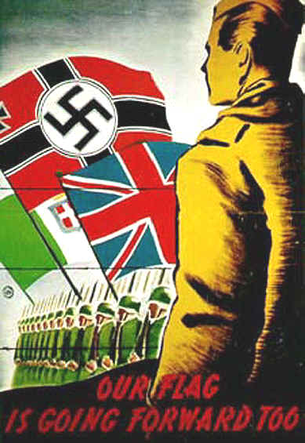

This detachment commenced formation in the second half of 1943 when the strategic-military situation of Germany had greatly deteriorated. Volunteer POWs from Great Britain and her dominions became the main source of servicemen for the detachment. The first Commander of the Corps was Hauptsturmfurer SS Hans Werner Roepke an English-speaking German.

Officially the British Free Corps (BFC) was founded on the 1 January 1944. All up over the remaining 15 months of war 39 people served in it. Initially 6 men comprised the Corps: Thomas Cooper, Fransis MacLardy, Roy Courlander, Edward Martin and Alfred Minchin. It was so called ‘Big Six of rather hard line Nazi who were involved into recruitment of new members.

What kind of people were they?

Cooper, a son of an Englishman and a German woman, applied to join Police College, RN and RAF before the war but was rejected because of his partially German background. The disappointed man joined the British Union of Fascists (BUF) and in 1939 went to travel to Germany with his mother. His was caught by the war there and faced a difficult choice – to be interned as a British subject or to be drafted into the German Army. The chose the latter and later served in various detachments of the Totenkopf Division. In 1941 he was in Poland and later bragged of his participation in murders of Poles and Jews. He spent some time at the Eastern Front and was wounded.

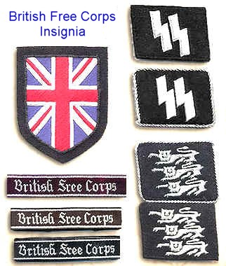

MacLardy, former pharmacist and BUF member from Liverpool was captured by Germans in Belgium in 1940 and in 1943 after a series of illnesses joined BFC having decided that he would not survive another Polish winter (his POW camp was in Poland VK).

Roy Courlander, a son of a Lithuanian Jew and an English woman was born in London, served in New Zealand Army and was captured in Greece in 1941. He posed as a White Russian émigré and was typical of extremely anti-Russian views. Before he joined BFC he had participated in the Nazi broadcast for England.

Little is known about the past of Canadian Edward Martin who was captured after failure of the Diepp landing. Alfred Minchin a merchant seaman from SS Empire Range was captured after his ship had been sunk en route to Murmansk. Later he told that he had joined BFC reckoning that it was purely a propaganda unit. Former Sergeant John Wilson was probably coerced into joining the Corps.

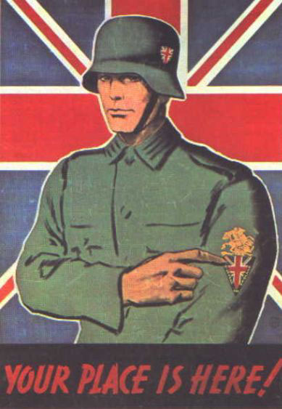

In February 1944 the Corps already numbered 8 free Britons although it is noteworthy that the composition of BFC had been constantly changing: people had been coming and going. Former boy seaman of the Royal Navy Kenneth Berry who was captured in 1940 when he was only 14 also joined the Corps. But already in March Martin quit and returned to POW camp. Soon a few more people joined the Corps: Robert Heighes, Robert Lane, Norman Rose, Wood (Australian) and Thomas Freeman.

The latter was fully acquitted after the war as he had managed to prove that his aim was sabotage the whole project and escape. Once upon a time he was a member of BUF and shared their anti-Communist and anti-Semitic views but during his time in BFC he really conducted anti-Nazi propaganda amongst his co-servicemen and instigated them to escape. Being involved in recruitment he would chose people whose interests were far from the aims of BFC and who as he told the British investigators later, would bring only chaos. Thus Freeman and Wilson recruited Australians Chipchase and Albert Stokes and Sergeant Theo Ellsmore Belgian who masqueraded as South African. Chipchase spent in BFC only several days and returned to the camp. Stokes was Freeman’s friend and initially intended to participate in sabotage of the project.

In spring 1944 the free Britons were involved in recruitment of new members in POW camps. During this period of time William How, former lance - corporal of Military Police, and Ernest Nichols who used to be a petrol storekeeper in the army, joined BFC. In May - June they were joined by former merchant seamen Herbert Rowlands and Roland Barker (Australian). Ironically enough Rowlands fought in Spain in the ranks of International Brigade during the Civil War, deserted it and later joined BUF. Barker was later characterized by Cooper as a man of very low intelligence he joined BFC attracted by prospects of an access to better food, alcohol and women.

In June John Leister and Eric Pleasants joined. Pleasants was a former member of BUF and in the past refused to serve in the army on the ground of his pacifist views. Leister was born in London in a German family, in 1935-36 he lived and studied in Germany. Pleasants and Leister worked on one of the British islands in the English Channel (doing alternative service) in 1940, found themselves in the area of German occupation and managed to have looted a few houses abandoned by refugees and finally, when attempting to escape to England on a motorboat, were captured by Germans and sent to a prison in France for six months. They eventuated in prison camp for merchant seamen. They joined BFC because of the same reasons hoping to have better food, alcohol and access to women.

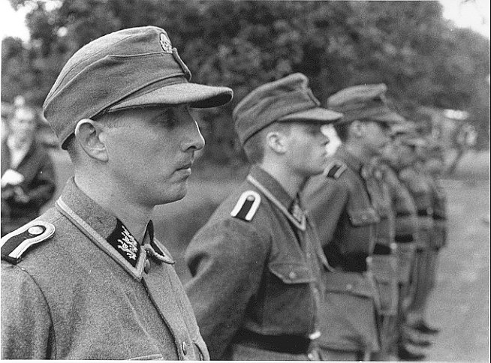
"Free Britons” in SS uniform - second right - Alfred Minchin, second left - Kenneth Berry

Amongst the novices of the spring-summer draft were also Harry Dean Bachelor, former sapper, Hugh Cowie (previously made several attempts to escape and joined BFC to avoid court-martial for possession of banned radio-set); Roy Futcher (joined of fear to be court-martialed for relations with German women); Frank Maton, before the war a BUF member, later corporal in commando units and participant of Nazi broadcasting for England; and Tom Perkins, former lance-corporal of Military Police. Out of these people only Maton was distinguished of his pro-Nazi convictions. In June BFC reached numbers of 27 people.

At this moment Freeman and Ellsmore wrote a letter with a request to return the volunteers to POW camps. It was signed by 14 people and after that the German authorities were accused of mutiny and sent to isolation camp in Stutthof. Freeman escaped from this camp in November 1944 and finally reached the Russian lines. He was repatriated to Britain in March 1944.

Hot debates and even punch-ups between the Big Six and other Britons were quite typical. Drinking was a considerable problem in the Corps as well.

Three of four Britons who joined the Corpse in August were blackmailed into it.

Frederic Croft, former artillery soldier, agreed to join after 5 (!) unsuccessful escapes and a long solitary confinement out of which he had little chance to get out. Edward Jackson also faced a choice between court-martial for an affair with a German woman or BFC.

Scotsman Charlie Munns was in the same situation but since his lover got pregnant he had a chance to face a firing squad. The fourth man Lieutenant William Shearer hit BFC straight out mental hospital. This poor schizophrenic returned to hospital only several weeks spent in BFC.

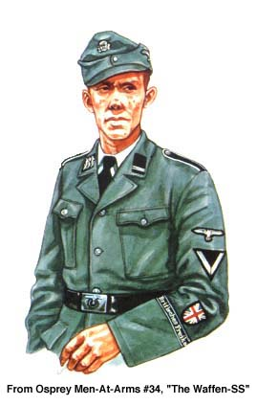

The Allied landing in Normandy exerted very negative influence on the morale of the free Britons. Even the Big Six men began to talk about necessity to get back to England before the news about their treason reached the homeland. In August Tom Perkins was dismissed from BFC and sent to isolation camp for stealing a pistol (it was sold to a foreign worker). Also in August Pleasants, Leister, How, Rose, Futcher, Rowlands and Croft were sent the SS penalty camp near Schwerin to work in a road gang. Lane was simply returned to POW camp.

These incidents reduced the Corps numbers by one third.

By September 1944 the members of Big Six had got tired of struggling with their obdurate ‘free Britons. The most ardent Nazi MacLardy left the Crops and joined a medical detachment of SS. And Courlander and Maton merely escaped to the frontline in a train moving the Flemish SS-Battalion to Brussels. On the 4 September 1944 they gave themselves up to the British troops.

However, in the end of September two new members joined the Corps: William Alexander and Harry Nightingale and again due to the same reason unwillingness to bear responsibility for sexual liaisons with German women. Soon BFC was transferred to Dresden for combat drill. Beside of it, the free Britons were not forgetting about entertainments and sports.

In November Cooper who had been trying hard to leave the Corps was dismissed from his commanding position. He was accused of anti-Nazi activities but eventually he commenced services as a Military Policeman. He was to meet his BFC mates in the last days of war.

In November most of the mutineers returned headed by Pleasants (he shortly after that married a German woman). They were missing Perkins who stayed in the camp, and Rowlands who had escaped and hid himself in one of Berlin suburbs. Along with them a new member South African Pieter Labuschagne arrived. In December 1944 - January 1945 William Miller who had preferred it to a 4-month term in prison, and another South African Lawrence Viljoen joined the BFC.

The motives of enlistment of three other volunteers are of some interest: South African Douglas Mardon was under influence of strong Russophobia he had acquired during contacts with the Russian POWs. George Croft and John Sommerville had been in POW camp from 1940, managed to have learnt German well and worked as camp interpreters. In this connection they were constantly threatened by other POWs and unruly gangs (there were some involved in robbery and rape VK) what led them to BFC.

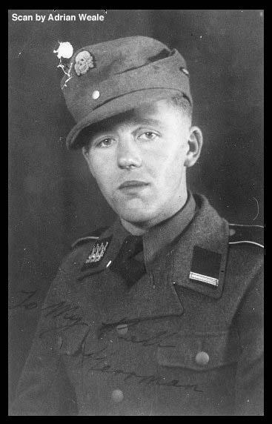

Thus in January 1945 BFC reached its highest numbers over its whole history 27 men. A bit later six Maoris from New Zealand nearly joined the Corps but were rejected by Australian Barker who announced that BFC was for whites only.

Nevertheless, the Corps was still shaky. The war was nearing its end and a group of free Britons decided to escape in order to reach the Soviet lines and give themselves up. The escape failed, Cowie, Futcher and Alexander were captured and sent to isolation camp, the rest were returned to BFC. A new volunteer arrived Alexander MacKinnon who had been enforced to do it under threat of court-martial for sabotage, but Charlie Munns left to unite with his fiancé in Danzig and little is known about his fate.

On the 12 February Dresden was destroyed after mass aerial bombardment. Viljoen found himself in hospital with burns. Britten who had been planning an escape for quite a while admited it to his girlfriend a Norwegian nurse and added that he knew about the oncoming air raid. She did not hesitate to give him away to Gestapo and after that nearly the whole lot of BFC men were arrested; Heighes and Howe managed to escape. They mixed up with a POW column evacuating to the West.

But the history of BFC did not end at this point. The arrested men were released from prison and transferred to Berlin: the authorities decided that it was time to throw them into combat. At this moment another volunteer arrived. It was Frank Axon who had joined under threat of punishment for hitting a cow that allegedly had calved prematurely due to it!

The free Britons did not favor too much the prospect of fighting against the advancing Red Army. Simons, Rose and Nightingale convinced the authorities to return them to POW camps. Pleasants and Leister were transferred to different detachments of the Propaganda Ministry of the collapsing Third Reich.

For four days the BFC was drilled to handle Panzerfaust and new assault-rifle MP44. Finally, on the 15 of March BFC having fitted into one truck, headed to the front into its crusade against Bolshevism. After arrival the Corps was billeted along with the III (Germanisches) SS-Panzer Korps manned by Germans, Danes, Dutch and Norwegians. Over this period of time the Corps lost one more fighter as George Croft departed to cure his exacerbated gonorrhea.

On the 22nd of March the Corps was sent to reinforce a reconnaissance Battalion which was in reserve of the SS-Division Nordland the most multinational detachment of the SS-Waffen. Four more weeks were spent in anticipation of fighting and the Corps lost the rest of its battle enthusiasm.

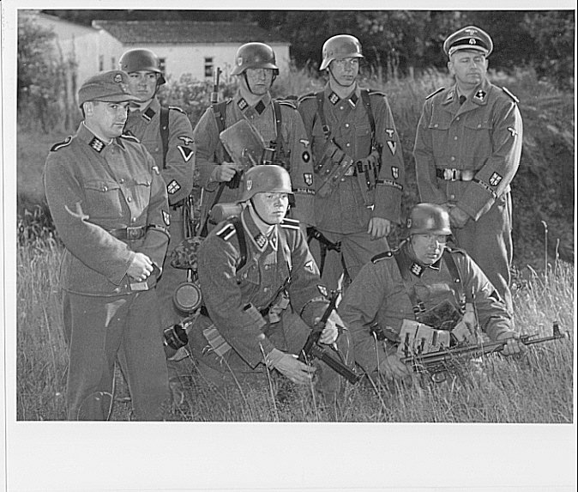

And at that moment Cooper entered the scene again. Having been ordered to go to the front on the 6th of April, he took a civil suit with him and departed to the location of the III Panzer Corps. Here he was stunned by the order to visit BFC.

Conversing with his mates he talked them out of the idea of escape knowing far too well that there would be no mercy to deserters in the hands of Military Police. He managed to convince Brigadefurer SS Ziegler Commander of the Panzers that BFC had little fighting efficiency, was morally unstable and that it would be better to withdraw tem from front. Ziegler agreed and the free Britons were withdrawn to Templin.

On the 19th of April the last action hero of this drama entered the scene. A man named Douglas Berneville - Clay and dressed into the SS-Hauptsturmfurer uniform arrived to BFC. He was former Second Lieutenant of British Commandos captured in North Africa. Before the war he served in the army, quit and returned to the forces again. In the meantime he did not have a clean criminal record, as there were thefts, bigamy and various machinations on his account.

When in POW camp he was unmasked by his inmates as a German informer and removed from the camp by Germans themselves for his own safety. It is unknown what had happened to him between then and the 19th of April 1945. It is known that he was eager to lead BFC into battle but Cooper stopped him. Soon he disappeared with MakKinnon and in several days surrendered to the Allies.

On the 2nd of May Cooper and the remnants of BFC gave themselves up to the Americans near Schwerin. By this time Bachelor and Stokes had already left the unit. Finally the British Intelligence arrested 27 men involved into the BFC activities. Eric Pleasants found himself in the Soviet occupation zone, was arrested early in 1946 suspected of espionage and spent seven years in a prison camp near Vorkuta.

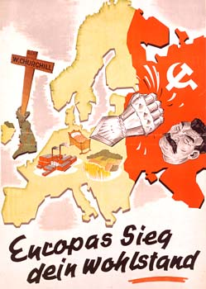

The post-war fates of the free Britons went different ways. Cooper and MacLardy received life sentence, but the former certainly had said nothing about his wartime participation in punitive actions in Poland to the investigators.

He was released in 1953, and Maclardy’s term in jail was later reduced to 15 years. Britten got 10 years but was soon released because of illness. Wilson got 10 years, Symonds 15, Berry (the youngest participant of the story) 9 months. Canadina Martin got 25 years back in their homeland; South Africans Mardon, Viljoen and Labuschagne were acquitted (the latter, though, was fined 75 pounds). New Zealander Courlander spent 7 years out of his 15-year term in jail and then used to go to pubs bragging about his service in SS. Australians Stokes, Chipchase and Williams were not preceded at all as well as most of the free Britons. It is noteworthy, that Berneville-Clay was acquitted because of lack of evidence against him, rested in the army but only in year discharged for theft.

The battle path of BFC seems to have been no more than a curious historic incident. In reality, this small group of people was a drop in a bucket. Nearly all POWs from Great Britain and her dominions remained loyal to their oath and the prospect of fighting against the world plutocrats and Bolsheviks or crusade against Russia never inspired them to anything despite significant efforts of the Nazi propaganda.

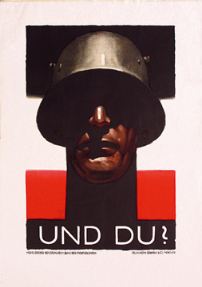

Appendix

John Amery's Proclamation of the Legion of St George

BRITISH NATIONAL REPRESENTATION

PROCLAMATION TO ALL BRITISH SUBJECTS INTERNED

FELLOW COUNTRYMEN:

150,000 of our fellow countrymen are in prison in the home country, because they have declared themselves against this fratricidal war. In violation of the Habeas Corpus Act and the fundamental laws of our constitution these men have never been brought to trial or even allowed to see a lawyer.

American troops brave not only occupied Ulster but also are arriving in increasing numbers in England.

Naval bases and Colonies have been handed over to Mr. Roosevelt's administration.

BEYOND ALL THIS

This war has ceased to be a war of nations but has become a war of CONCEPTION

Europe and our country, your wives and children at home are menaced by the invasion of the HORDES OF BOLCHEVICK BARBARITY.

For this reason I have approached the German Government with the proposal to form A BRITISH LEGION AGAINST BOLSHEVISM, to be known as the LEGION of ST GEORGE.

I appeal to all Britishers to answer this call to arms for the defense of all the principles that we Englishmen have been the first to proclaim in the world.

THE DEFENCE OF OUR HOMES, OF OUR CHILDREN AND OF ALL CIVILISATION AGAINST THE DRAGON OF ASIATIC AND JEWISH BESTIALITY.

The St George Legion will fight only against the Communists and on NO OTHER FRONT!

All men will commence in their present rank and promotion will be open to all men alike, without any distinctions or qualification, political or otherwise. Within the limits of the military possibilities the Legion of St. George will fight at the junction of the German - Finnish front, beside the troops of the undaunted liberty loving Finnish people.

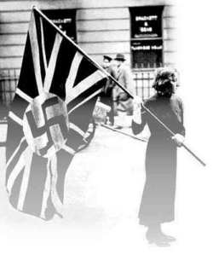

The British Representation in Berlin formally guarantee to all ranks: A PERMANENT WELL PLACED JOB IN THE BRITISH ADMINISTRATION OR A PRIORITY IN ANY OTHER EMPLOYMENT THEY SHOULD DESIRE ONCE PEACE IS SIGNED, OR THE POSSIBILITY TO FORM THE ELITE IN THE NEW BRITISH ARMY.

Hundreds of soldiers have volunteered to join this Legion. Men who have escaped to England have come to join us. Three Royal Air Force aeroplanes have come over to us so far with their arms and equipment.

It is up to you civilians to give a hand to show that we intend to take our responsibilities to maintain THE INTEGRITY OF OUR EMPIRE, by giving the world proof that we have not all sold out to the JEW OR PLUTOCRAT.

I ASK YOU TO OPT NATIONAL

The British Representation which is a 100% British organization will take no steps whatever of intimidation against the persons who do not opt, BUT fellow countrymen the world is watching us, EUROPE EXPECTS THAT EVERY CIVILISED MAN WILL DO HIS DUTY, National England desires that you will show yourselves worthy of Nelson's immortal signal:

ENGLAND EXPECTS THIS DAY EVERY MAN WILL DO HIS DUTY

Your place is with us Nationalists.... Your duty is to opt NATIONAL under the glorious banner of St George we are going to write a new page in the History of the British Empire: more, WE SHALL SAVE THE BRITISH EMPIRE FROM COMMUNISM AND AMERICAN RAPACITY.

We shall show the world that free Englishmen:

NEVER, NEVER WILL WE BE THE SLAVES OF A JEWISH PLUTOCRATIC TYRANNY; WE ARE WORTHY DESCENDANTS OF THE YEOMEN THAT DICTATED MAGNA CHARTA.

Pay no attention to wavering or opposition: the first to opt will be the examples of bravery and courage to those that now waver or are against us but who will have to join us one day when they realize all the truth. In these fatal days when we are before the bar of civilization: I beg, I demand, that you put aside all hesitations, all the prejudice, all the lies that have led you where you are ... that you take this IMMENSE OPPORTUNITY THAT I HAVE OBTAINED AND WITH ME, WITH ALL THOSE THAT HAVE ALREADY JOINED.

YOU WILL OPT NATIONAL FOR ENGLAND AND ST GEORGE!

PARIS 20-4-43
John AMERY

*St George Legion initial name of the British Free Corps

**John Amery one of the most prominent British renegades, an ardent Nazism and Nazi-propagandist during WWII. Sentenced to death by the British Court and hanged on the 29th of December 1945.

