Nelson Crocker and the Panthers. 151

are generally found singly, or at most in pairs, Crocker could not conjecture why so many were together. He followed the tracks until he was hungry, and then sat down to eat his luncheon. Dividing this into two parcels, he proffered one to his dog; but the latter instead of sharing the tempting meal, showed his teeth, and seemed bristling for a fight with an unseen enemy. Just as the hunter swallowed his last mouthful, a large panther sprang by him, almost grazing his shoulder as it passed. Crocker caught up his rifle, fired at the beast at random, and saw it disappear unharmed. An instant afterward his dog was fighting another of the monsters at a little distance; but the dog was soon glad to get out of reach of the claws of his antagonist and run to his master for protection.
As Crocker was reloading, he saw a third panther corning toward him. He shouted at the top of his voice, and it ran up a tree. This one he shot and killed. As soon as he could reload he caught sight of another, which he also shot and brought down from its perch in a tree. Here the fright of the dog, which seemed to feel safe nowhere but between his master’s feet, and the screaming of the panthers in every direction, caused Crocker to lose heart. To get out of that swamp without delay he believed to be his first and supreme duty. He ran with all his might for safe ground, and did not stop until he believed himself out of the reach of danger.
The next day Crocker returned to the scene of this adventure for the purpose of skinning his game. While thus engaged he discovered a large male panther in the crotch of a tree. He fired at the beast and it fell; but it immediately ran up a sapling until the top was reached, when the sapling bent with the weight of the beast until its branches reached the ground. As the panther came down, the dog, forgetting the rough usage of the previous day, stood ready for battle. A rough-and-tumble fight ensued, in which the dog was speedily whipped, when he fled yelping toward his master, closely pursued by the panther. Crocker’s rifle was unloaded; and as he had no relish for a hand-to-claw encounter he concluded to run too. A race ensued in which the dog was ahead, the hunter next, with the panther in the rear, driving all before it. Crocker expected every moment to feel the weight of his pursuer’s claws on his shoulders, and consequently made excellent time. Finding his rifle an encumbrance, he dropped it as he ran. This proved his salvation; for the beast stopped a moment to smell at it, and decide whether it should be torn in pieces. This enabled Crocker to get out of the swamp before the panther could overtake him, and the beast did not seem inclined to follow him to the upland.
After waiting some hours, Crocker, armed with nothing but his hatchet and hunting knife, started once more for the swamp from which he had twice been driven ingloriously. Recovering his gun, he reloaded it carefully, and endeavored to induce his dog to follow the panther’s track; but he declined, having had enough of panther hunting. As they were leaving the swamp the dog commenced to howl. The panther answered with a loud squall, and started towards the hunter, repeating the challenge as it came, evidently bent on a
152 Legends of the Shawangunk.

fight. The dog crouched close to the feet of the hunter, while the latter coolly awaited the approach of the ferocious monster. When it was within one bound of him, and about to spring, Crocker sent a ball crashing into its brain. Without further adventure he skinned the game he had shot during his two days’ hunt, and returned home.

THE DISAPPOINTED GROOM.

WALTER MANNING was a native of Ulster county. At the age of twenty he fell heir to a property of several thousand dollars. Disregarding the advice of his friends to let his inheritance remain in real estate, he converted most of it into cash, and started for the west to make a more colossal fortune. In due time he arrived in California. His talkativeness soon apprised the people of the town that he was a young man of property, which he proposed to invest when a desirable occasion offered. It was not long before a speculator, who had landed property on his hands that was quite slow of dividends, by dint of much flattery and persuasion, convinced young Manning that his was just the property he required, and that it was certain to bring rich returns in the near future. The result was that Walter paid a large portion of his patrimony for the estate, and set up his pretensions as a landed proprietor. The next essential for house-keeping was a house-keeper, and Walter cast about him for a wife. A young man of reputed wealth, with a large estate and money in bank, good looking and accomplished, ought to be in no lack of young ladies willing to share his fortunes. And so it proved in the case of young Walter. Mothers with marriageable daughters vied with each other in their attentions to the young landholder; he was invited to teas, plied with calls, and in short was lionized by the female world generally.
But Walter Manning, with all his wealth, his devotion to the sex, and the largeness of his philanthropic soul, could not marry them all. He must needs single out one of the number of the number of his admirers, and content himself with the love and adoration of her alone, so unreasonable and circumscribing are the marital regulations of modern society. Among the most beautiful and accomplished of those damsels, he thought Virginia Green the most to his liking. She was a blonde, possessed a petite figure, bore the reputation of a superb dancer, and withal was an excellent conversationalist. As soon as Walter’s preference became known, he was no longer invited to afternoon tea-parties. The mothers of marriageable daughters were fain to pass him unrecognized. But if he had lost caste in the eyes of the feminine public, he was more than compensated by the smiles and caresses of Virginia Green. Not a day passed but he was found in her society; and what his passion overabounded in intensity,
The Disappointed Groom. 153

her affection counterbalanced in devotion. In short they became engaged. And now that the matter was settled, why delay the day of nuptials? When love was so fervent, the mansion in want of a mistress, and a bachelor heart so much distressed for lack of a ministering angel, procrastination was a loss to all concerned. Walter pressed his suit for an early wedding, and the young lady, after a show of reluctance which amounted to nothing, appeared to bend to his desires.
“But,” said the young lady, “you know that fortune is fickle, more inconstant even than affection. Why not bestow upon your future wife a marriage portion! It will be yours to enjoy as though held in your own name, and should fortune fail you, you will have something saved from the wreck, to fall back upon. Besides, it will be a slight token of the sincerity of your professions of love to me.” “That I will readily do,” said Walter. “I’ll give you the deed to this estate, to be given you at the altar on the day of your nuptials, to be celebrated at the parish church next Thanksgiving Day, two months hence;” to which she assented in tones of never-dying affection.
Now followed the busy note of preparation. Numerous journeys to the metropolis, a half score of milliners, dressmakers, hair-dressers, and assistants were found necessary to bring out a trousseau suitable for the future mistress of Redwood Hall. The coming wedding absorbed the talk of the town; and Walter thought himself fortunate in that he could now revenge himself for the slights of his former admirers, by leading the most beautiful of them all to the altar. Every body received cards of invitation; and no less than three clergymen were invited to be present, that there might be no hitch in the ceremony.
Thanksgiving Day arrived at length, and a most auspicious day it proved. The air was bland, the sun shone brightly, and nature seamed to don a holiday attire in keeping with the occasion. The church was gaily trimmed; carpets were spread from the doors to the carriage-way, and the pews were literally crammed with people clad in fashionable attire. The organ pealed forth its most joyous wedding march, and presently aflutter in the audience showed that the contracting parties had arrived. As the bride swept up the aisle, a bewilderment of feathers, lace and white satin, a murmur of admiration ran through the entire assembly. And, too, the manly bearing of Walter was such as to cause a perceptible flutter in the hearts of more than one damsel present.
As they took their places in front of the altar, and just as the highest flourish of the Wedding March was reached, Walter took a package from his pocket and gave it to the woman at his side. It was the deed of Redwood Hall, made over to Virginia Green, made to her before she was his bride, as a husband may not transfer real estate to his wife.
The last notes of the organ died away in semiquavers among the arches of the ceiling when the minister stepped forward and in solemn tones said, “Let the parties join hands,” and in a moment continued, “If any one have reasonable objection to the marriage of Walter Manning and Virginia Green, let him now make it known, or forever hold his peace.”
154 Legends of the Shawangunk.

A pause ensued in which the silence became oppressive. Presently a voice was heard. It was that of a young man in the rear of the audience. “I object to the bans.” All eyes were turned in the direction of the speaker. “State the grounds of your objection,” said the officiating clergyman with forced composure. “On the ground that the lady at the altar is already my wife,” was the calm reply. And then all present knew a wrong had been done that robbed Walter Manning, in one moment, of a bride and an estate. In one hour’s time, the disappointed groom had arranged his pecuniary affairs, and was on his way with the remains of his fortune to his home in the east.
The statements in the foregoing narrative are based on facts. The names only, for obvious reasons, are fictitious.

NEW PALTZ.

ON the 26th of May, 1677, an agreement with the Esopus Indians was made, pursuant to a license from the Hon. Governor Edmund Andros, dated 28th of April, 1677, concerning the purchase of land “on the other side of the Rondout kill,” known in history as the “Paltz Patent.”
Matsayay, Wachtonk, Senerakan, Mayakahoos and Wawawanis acknowledged to have sold Lewis Du Bois and his associates the land within the following boundaries: Beginning at the high hill called Moggoneck [Mohonk], thence southeast toward the Great river to the point called Juffrow’s hook in the Long beach, by the Indians called Magaat Ramis [point on Hudson river on line between the towns of Loyd and Marlborough]; thence north along the river to the island lying in the Crum Elbow at the beginning of the Long Reach, by the Indians called Raphoos [Pell’s island]; thence west to the high hill at a place called Waraches and Tawaeretaque [Tower a Tawk, a point of white rocks in the Shawangunk mountain]; thence along the high hill southwest to Maggoneck, including between these boundaries, etc.” This tract the Indians agreed to sell for the goods specified in the following list:
40 kettles, 40 axes, 40 addices, 40 shirts, 100 fathoms of white wampum, 100 bars of lead, 1 keg of powder, 60 pairs of socks, 100 knives, 4 ankers of wine, 40 guns, 60 duffel coats, 60 blankets, 1 schepel of pipes, etc.
Having thus extinguished the Indian title to this tract by the present of articles valued by the red man, the settlers of New Paltz enjoyed a comparative immunity from savage outbreak during the early wars. In order to arrive, however, at a more complete understanding of the history of this settlement, reference will be made, in brief, to an event in the chronicles of the old world.
The French Protestant Huguenots were celebrated for their love of liberty and zeal for their chosen religion. Persecutions against them were temporarily abandoned during the deign of Henry IV, King of Navarre, from 1589 to 1610,

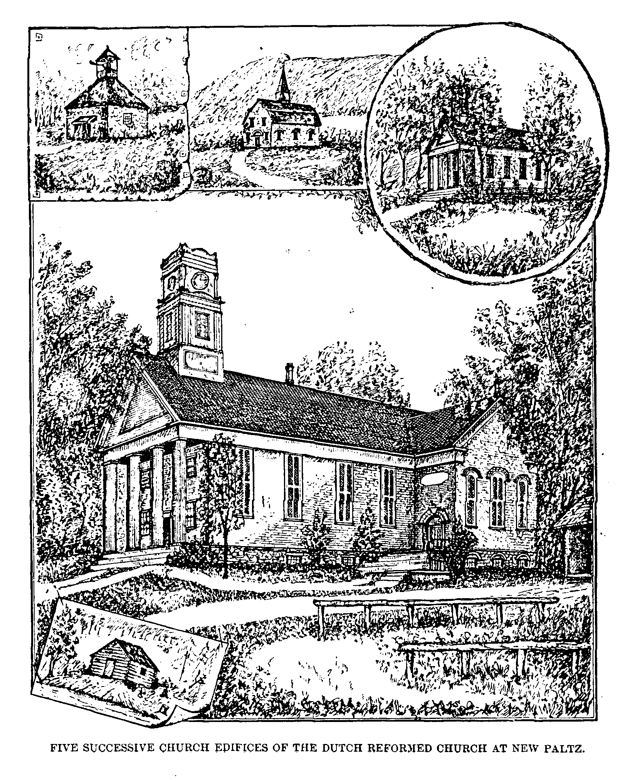

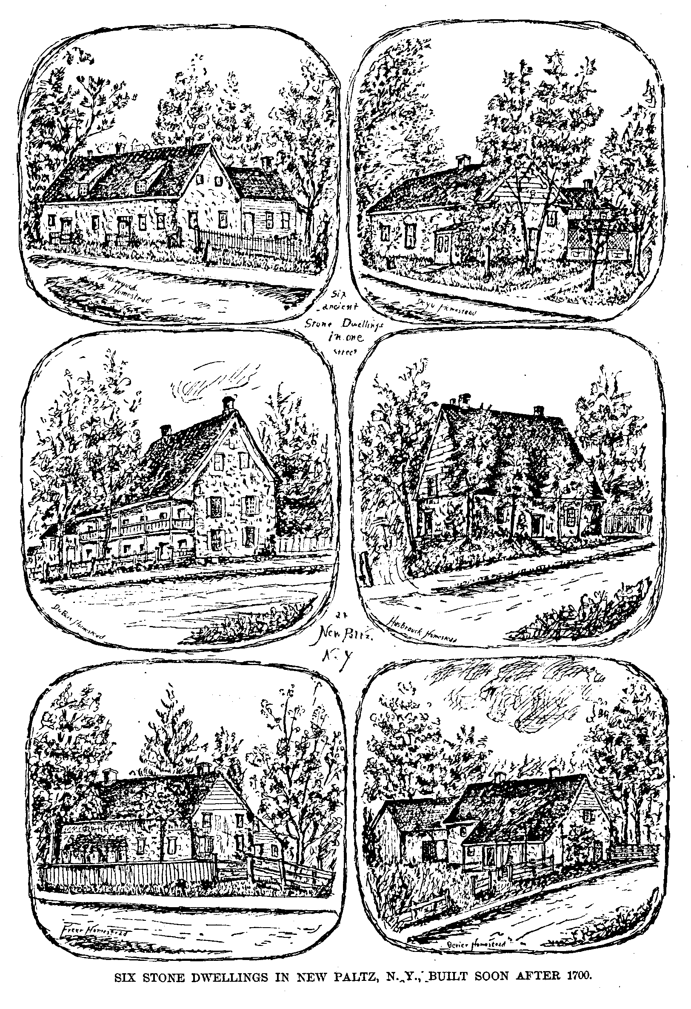

New Paltz. 155

especially after he proclaimed the celebrated Edict of Nantes in 1598. Louis XIII repeatedly violated its stipulations; and a formal revocation of the Edict was made in 1685, which cost the lives of 10,000 of the Huguenot people, who perished at the stake, gibbet, or wheel. Thousands fled to other lands for refuge, especially to the Lower Palatinate, or Pfaltz, along the river Rhine. Some of the persecuted Hollanders likewise fled to the Lower Palatinate, and when they subsequently returned to Holland the Huguenots accompanied them, and both finally emigrated to America. These two peoples were attracted to each other by reason of their adoption of the same religion, and this fellowship was rendered still more firm in consequence of the free intermarriage among them. This accounts for the presence of Dutch physiognomies with French names, observable, even at the present day, among the congregations in localities where are found the posterity of the once persecuted Huguenots.
There seems to be no definite information as to the course the Huguenots took in coaxing to America. They were hospitably received by the Dutch at Wiltwyck, or Wildwyck, the modern Holland for wild retreat, or wild parish, from its primitive and rough appearance. Soon after the granting of the New Paltz patent the Huguenots set out for their new home in the wilderness. Their weary way lay through the trackless forests; and their families and household goods were conveyed in wagons so constructed as to answer the double purpose of transportation and shelter. Arriving at a broad meadow on the banks of a limpid stream they named the place “Tri-Cors,” Three Cars, in allusion to the three primitive vehicles in which the possessions of the exiles were transported. The river itself they named Walkill, probably from Wael, one of the branches into which the Rhine divides itself before emptying into the North Sea, and Kill, the Dutch for river; while to the settlement was given the appellation of New Paltz, in remembrance of their ever dear Pfaltz—their ancient home on the Rhine. Here, in the midst of the beautiful alluvial valley, the crystal waters of the river at their feet, the blue dome o£ heaven above them, and the towering hills a gallery of attendant witnesses, the Huguenot refugee opened the Bible brought from their old homes, read a lesson from the holy book, and with faces turned toward France, joined in a hearty and joyous thanksgiving to the God that had led them safely thus far, and had permitted them once more to breathe the air of religious freedom.
The first conventional act having been that of public worship, it was resolved that their first building should be a church. This was built of logs, and was also used as a school-house. Temporary residences were at first put up an the west bank; but the Indians advised their removal to the higher ground on the opposite side, as the place first chosen was subject to overflow during the spring freshets.
From a minute in French, still in possession of the church, we find that on January 22, 1863, M. Pierre Daillé, Minister of the Word of God, arrived and preached twice at New Paltz. He proposed that the people choose, by a vote of the fathers of families, an elder and a deacon, to aid the minister in the
156 Legends of the Shawangunk.

management of the church. They chose Lewis Du Bois, elder, and Hugh Frere, deacon. Thus was organized the Walloon Protestant Church of New Paltz, and for fifty years service was held in the French language. But the Holland tongue had become the vernacular in Ulster and adjacent counties, and gradually became adopted by the Huguenot settlers of New Paltz. The first Dutch entry in the church bears date of the 6th of July, 1718. During the period intervening between 1709 and 1730, there was no stated supply at New Paltz; the earnest Christians were obliged to go to Kingston to attend preaching—whither they often went on pious pilgrimage.
Rev. Stephen Goetschius accepted a call from the congregation, at New Paltz and New Hurley. His ministry healed the breach that threatened to disrupt the church at New Paltz. He is described as small in stature, and bent in form. He boarded at the home of Lewis Du Bois, and married his daughter. He was a sound preacher, and occupied a high place in the estimation of his people. His vacant sabbaths were spent at Wawarsing. At that time the Indians were visiting the defenseless inhabitants with fire and slaughter. Goetschius writes of preaching in a pulpit cut and disfigured by the tomahawks of the savages; the church itself showing evidences of having been set on fire by the same agency, but which providentially went out. He further writes: “At the close of the war I perceived there were places where new congregations might be gathered. I did undertake to collect the people together, and under the blessing of God organized nine churches.” At that time Goetschius was the only minister in the Dutch church in Ulster.
The log church was soon found to be unequal to the demands of the growing colony. A new church was built of stone, “of small dimensions,” the records say, “and finished with brick brought from Holland. Its form was square, each of the three sides having a large window, and the fourth a door inclosed by a portico. In the centre of the steep and pointed roof was a little steeple, from which a horn was sounded for religious services.” This was dedicated December 29, 1720. October 25th, 1771, it was resolved to erect a third house of worship. The site of this edifice corresponds nearly with the location of the present church, and is described as having been a “substantial, well proportioned stone building, with a kipped roof, surmounted with a cupola, and a bell.” The building was dedicated in 1773. The old square church was broken down, and the material used in the construction of a school-house, which was afterward converted into a residence. It is worthy of note that both churches were built while the people were without a pastor.
It was during the ministry of Rev. Douw Van Olinda, a gentleman of marked executive ability, that the New Paltz academy was erected and put into active operation; and he was largely instrumental in carrying forward the project to a successful termination. During his pastorate the third church was taken down and a new brick church erected on its site, which constitutes the eastern extension of the present house of worship.
There were twelve original proprietors of the New Paltz patent. These
Needderduytse Taal Te Shawankonk. 157

twelve patentees exercised the governmental control of the colony, one of their number presiding, constituting what was known as the “Dusine,” a primitive form of civil administration, out of which sprang the Town Meeting of New England. Most of them constructed substantial stone dwellings along one street, now known as Huguenot street. Six of these stone edifices are yet standing, and are shown in the accompanying illustrations. The Holland bricks, the quaint little Dutch windows with glass set in lead, and the ancient portholes in the walls of the houses, are yet shown to curious visitors, and yearly attract scores of antiquarians to the locality.

NEEDDERDUYTSE TAAL TE SCHAWANKONK.

LOW DUTCH CHURCH OF SHAWANGUNK.

THE Reformed Church of Shawangunk was organized in 1750, and the present church edifice—the oldest in the consistory—was built the same year. The society first worshipped in the “Owl house,” a temporary structure near the kill. Johannis Mauritius Goetschius came over from Switzerland and organized the infant church in the wilderness. Barent Frooman, a native of Schenectady, was called to the pastorate at Shawangunk, New Paltz and Walkill [Montgomery], February 4th, 1751. He was sent that same year to the University of Utrecht, where he remained two years. He started home in company with Jacobus and Ferdinandus Frelinghuysen, and Johannis Schuneman. The first two died on shipboard of small-pox. Frooman preached at New Paltz August 26, 1753, at Shawangunk September 2, and at Walkill [Montgomery] September 9. No record is given of any installation. His salary was fixed at £90, one-third to be raised by either church. He lived at Shawangunk, now Bruynswick, a house and one hundred acres of land having been set apart there for his use. He married Alida, daughter of David Vanderhyken, of Albany. He was called to Schenectady in 1754, and died at that place in 1784, in the sixtieth year of his age.
Rev. Johannis Mauritius Goetschius was born in the Canton of Thorgan, Switzerland, in 1724. He studied and practiced medicine before he entered the ministry, but was drawn to the study of theology and began to preach without due authority in 1754. He was a warm advocate of the Coetus principles, and three years later was called to the pastorate at Scoharie at a salary of £60, parsonage house, one farm, and 40 schepels of wheat.
Goetschius was called to Shawangunk and New Paltz in 1760. He lived in the Shawangunk parsonage, then one story high, and was paid a salary of £80, one-half borne by each church. He died at the parsonage March 17, 1771, of dropsy. He was long sick, and was a great sufferer. He preached the last time at New Paltz September 9, 1770. During the ten years of his ministry he
158 Legends of the Shawangunk.

baptized 320 persons at Shawangunk, and married 75 couples; at New Paltz he baptized 212 persons, and performed 41 marriage ceremonies. He was buried under the pulpit of the Shawangunk church, in accordance with the ancient custom of the society, where his ashes still repose. His widow, Catherine Hager, continued to live at Shawangunk, and married her husband’s successor, Rev. Rynier Van Nest.
Van Nest, the third minister, was early converted, but studied late in life for the ministry. He was for several years clerk in a country store at Bound Brook. He was licensed by the Synod of Kingston October 7, 1773, receiving his call to preach at Shawangunk and New Paltz April 16, 1774. His stipulated salary was £60 and parsonage; New Paltz was to pay £20, and the service was to be divided accordingly. The records say he baptized 384 persons at Shawangunk, and 45 at New Paltz. His labors seem to have extended to Montgomery, where he performed 307 baptisms. His pastoral connections were dissolved by the Classis in April, 1785. His personal appearance is described as follows: height, five feet, ten inches; fleshy as he advanced in age; wore a wig, and was very neat and particular in dress; possessed regular features, with a somewhat prominent nose; he spoke with a loud voice, and was considered a good preacher when speaking in Dutch, but never succeeded well in English. He was held in high estimation. The fourth minister was Rev. Moses Freligh, who was licensed to preach in 1787 by the Synod of New York city, called to preach at Shawangunk and Montgomery February 20, 1788, and was ordained in the Shawangunk church the same year by Rev. Blauvelt Rysdyk, Steven Goetschius and De Witt. First baptism at that place was a child of George Upright and Maria Rhinehart; first baptism at Montgomery, a child of William Christ and Elizabeth Decker. Freligh married Sarah Varick, of New York, in 1788, and died at Montgomery February 10, 1807, at the age of 54 years.
Rev. Henry Polhemus next succeeded to the ministry. He was born at Harlingen, N. J., was licensed by the Classis of New York in April, 1798; called to Shawangunk January 23, 1813; installation service June 13th of that year, Rev. Moses Freligh preaching the sermon. Polhemus died in November, 1815. He had been to New Jersey, and on his way home was attacked with bilious fever. His remains were deposited under the pulpit, along with those of Goetschius.
The next in succession was Rev. G. B. Wilson, who was licensed by the Classis of New Brunswick, and was called to Shawangunk and Paughcaughnaughsink [New Prospect] in January, 1816. He was dismissed in 1829 on account of feeble health. The following is a list of ministers up to the present time, with the date of settlement; Henry Mandeville, 1831; John H. Bevier, 1833; John B. Alliger, 1845; Charles Scott, 1851; Cyril Spaulding, 1868; P. K. Hageman, 1882.
The stone edifice of this church has been subjected to changes suggested by modern taste. The ancient pulpit, beneath which the remains of the two faithful pastors, Goetschius and Polhemus, were deposited, was located on the
The Traps. 159

north side of the building, and the entrance was opposite the pulpit. An extension, surmounted by a spire, and partially enclosing the present entrance to the building and a stairway to the gallery, has more recently been added to the west end, and the pulpit moved to the east side of the structure.

THE TRAPS.

THERE is a singular and romantic formation on the top of the Shawangunk mountain known as The Traps. Quite a village has sprung up within its sheltering bosom, and boasts of a hotel, store and chapel. Benj. Burger and his wife Helena, were among the first settlers. They put up a log cabin and commenced housekeeping in a primitive way. At first the wild animals were so fierce that fires had to be kept at night as a protection to their cattle. A colt was killed by the blood-letting brutes, and the mare was badly bitten and torn. Burger sometimes worked for the farmers in the valley, and when he returned home at nightfall he was obliged to carry a torch to keep off the wolves. He used to tell of seeing their teeth as they gathered about him in the darkness and followed him up the mountain, growling and snarling, yet keeping at a safe distance through fear of his blazing pine knots.
On the east side, near to the highway leading over the mountain, there still stands a straggling building known as The Traps Tavern. Many years ago, a number of young men from the vicinity of High Falls were at this tavern, and were having a grand frolic. Their visit was protracted far into the night; and as the company seemed in no humor to depart, one of their number named Hill determined to go home. So, mounting his horse, he set out alone over the mountain road. While passing leisurely down on the opposite side, his horse began to prick up his ears, and exhibit other symptoms of alarm; and presently young Hill detected the stealthy tread of some animal that was moving in the underbrush by the roadside. He at last awoke to the fact that wolves were on his track; and, giving the reins to his horse, the frightened animal went galloping down the rugged mountain road at a breakneck speed. The iron shoes of his horse sent the sparks flying at every step; and the clatter of hoofs, the shouts of the rider, and the sharp quick cries of the wolves in close pursuit, startled the night air and awoke the sleeping echoes among the mountains. A false step, or a failure to retain his seat, and all would have been over for young Hill. In this way the cavalcade went dashing down the defiles, and finally brought up before another hotel at the foot of the mountain. Here the pack turned off into the forest, and the panting horse and terrified rider sought the friendly shelter of the hostelry until morning.
Some thirty years since the neighborhood of The Traps was the scene of a startling tragedy. Ben. Gosline, a man of middle age and married, became
160 Legends of the Shawangunk.

intimate with a young mulatto girl by the name of Maria Cross. One Sabbath afternoon he invited her to take a walk, and their rambles led them along the brink of one of the dizzy precipices with which the locality abounds. Arrived at a point of the rocks where the crag juts out three hundred feet in perpendicular height over the base, Ben remarked to his companion that he knew where was an eagles’ nest, and asked if she would not like to see it. Stepping aside he went to the brink, and, holding by a small sapling, leaned forward over the frightful chasm until he could see the face of the precipice. Presently he called out that he could see the nest, and that there were some young eagles in it. Unsuspicious of treachery, Maria took his place, and leaned over the edge as far as she dared, but failed to see the nest. “Stand a little nearer,” said Ben, “I will not let you fall.” So, taking his hand, she took a step forward until her head and shoulders hung over the beetling crag; at this moment Ben loosened his hold, gave her a gentle push, and, with a piercing shriek, the girl went over the precipice.
Providentially a hemlock tree grew out of the face of the rock, near to the bottom. into the thick branches of which the girl chanced to fall. The momentum of her descent was thus broken, so that she was not killed by the shock when she struck at the foot of the precipice. She managed to drag herself the distance of a few yards, where she lay in her agony until morning.
During the night she observed a light moving among the rocks where she fell, as though a lantern were being borne in the hand of some person there. Maria came to the conclusion it was her seducer and would-be murderer, searching for her mangled body. In the belief that Ben would yet kill her if he found her alive, she lay very quiet; and her visitor, after clambering a long time among the rocks, went away. In all probability it was Ben Gosline, who had come to remove all traces of his double crime. He doubtless concluded that she had escaped alive, or that some one had discovered and removed the body; in either case his only safety lay in immediate flight. Ben was never seen in the vicinity afterward.
The next morning, by dint of great exertion, Maria crawled over the broken ground towards the nearest house, when her cries of distress were fortunately heard. When found she was nearly exhausted, and her bowels trailed upon the ground as she urged her way along. Strange to say, she recovered from the effects of her fall; and it is believed is yet living in comfortable circumstances. Her child, born not long after the above adventure, lived to grow to maturity. The incidents of the attempted murder, and her miraculous escape from instant death, form themes yet fresh in the minds of the residents of the locality.
One day, late in autumn, the wife of Calvin Burger thought she heard the whir of a rattlesnake under the floor of their log cabin. She told her husband of the circumstance on his return, but he affected to believe she must have been mistaken. The snake continued to sound his rattle every day during the winter, whenever the heat from the stove warmed his snakeship into something like life; still the husband maintained at least an outward show of in-
The Traps. 161

credulity, knowing that any other course on his part would necessitate the taking up of the floor to search for the snake, or removing from the cabin. At length there came a mild day in spring. It chanced that Burger was obliged to be away from home on that day, but he directed his wife to watch for the snake, as he would most likely come out into the sunshine. Mrs. Burger kept a close watch, and was rewarded by seeing a large rattlesnake crawl out, through a chink in the foundation of her cabin. She found means to dispatch it, and proudly exhibited the remains of her late unwelcome guest to her husband on his return. The shake proved to be one of the largest of its species.
In the vicinity of The Traps are vast crevasses in the rocky ledges, some of them of unknown depth. These fissures vary in width from a few inches to as many feet, and constitute a feature of the natural scenery of the region. Table Rock is a cliff that apparently has been partially detached from the parent mountain by some convulsion of the past, but still maintaining its position, and rearing its head high among the surrounding elevations. At an early day an active and intrepid hunter by the name of Decker chased three deer to the edge of the precipice, two of which leaped from the rocks and were dashed in pieces at the bottom. The third, a huge buck, took up a position on Table Rock, and facing about, boldly defied his pursuer. Decker had thrown down his rifle in the haste of his pursuit, and had nothing but his hunting knife. Undaunted, be closed in with the buck, and a desperate conflict began. Grasping the deer by the horns, Decker essayed to cut the animal’s throat. The latter attempted to throw off his assailant, repeatedly lifting the hunter from his feet, at times suspending him over the brink of the precipice, so that he hung dangling by the buck’s horns. Again the hunter was obliged to exert his strength to prevent the deer from falling over. Long and uncertain the battle waged; at length the courage and agility of the hunter prevailed, and the life-blood of the buck reddened the face of the rock.
At the foot of the mountain, near The Traps, many years ago, lived a man by the name of Evans. In his employ was a negro boy named Jed, some nine or ten years of age. One afternoon Jed was sent up in the back lots to bring home the cows. Not returning after the usual absence, Evans went to look for the lad, and was horrified to find him bound to a bar post in a standing position by a huge black snake, and stone dead. The snake had probably attached himself to the post, and, as the boy attempted to pass through, it had taken a turn around the lad and squeezed him to death.
162 Legends of the Shawangunk.

SHANKS BEN.

JOHN MACK was an old resident of Wawarsing. John Mentz, his son-in-law, lived on the east side of the mountain. The only communication between the two families was by an Indian trail leading over the mountain, known as the Wawarsing path. Some time during the Revolution Mack started on a visit to his daughter, Mrs. John Mentz, accompanied by his younger daughter, Elsie. On their way they called at the house of a neighbor. While there, Elsie, who was dressed in white, catching a view of herself in the glass, declared that she “looked like a corpse.” As she was of a vivacious temperament, the remark impressed itself on the minds of her friends, some regarding it as a premonition of some evil that was to befall her. Without further incident they accomplished their journey, and made the contemplated visit.
On their return, John Mentz accompanied them as far as the top of the mountain, with two horses for the old man and his daughter to ride. Mentz proposed taking along his rifle, but was dissuaded from so doing by Mack, who thought it was not necessary. On arriving at the summit where they were to separate, the father and daughter dismounted, the former seating himself upon a log and lighting his pipe. Presently strange movements of the horses indicated they saw something unusual; and looking down the path over which they had just come, Mentz saw two Indians advancing, while a third, whom he recognized as the notorious Shanks Ben, was taking a circuitous route through the woods, so as to get in advance of them.
Mentz understood the significance of this movement, and realized the danger of their situation. He bitterly regretted he had not followed his own counsel, and brought along his rifle. He might easily have killed the two Indians in the path at a single shot. He had formerly been on intimate terms with Shanks Ben. They had hunted in company, and together had engaged in the labors of the farm; but a quarrel about a dog, and the bitter feeling engendered by the war, had contributed to destroy their friendship, and they were now sworn enemies. The old man, knowing it would be vain for him to attempt escape, sat still, resigned to his inevitable fate. Mentz started with Elsie in a direction designed to elude pursuit; coming to a precipice, he was obliged to leave the girl, in spite of her earnest entreaties that he would not abandon her, and save himself by jumping off the ledge some twenty feet in height. In his leap he injured his ankle badly, but succeeded in making good his escape. Mentz said he might have saved the girl had it not been for a little dog that followed them and kept constantly barking.
When Mentz came in sight of Colonel Jansen’s, he saw a number of men collected there. A relief party was immediately made up and dispatched to
Shanks Ben. 163

the mountain, where they found the bodies of the old man and blooming maiden, side by side, covered with purple gore, and mutilated by the tomahawk and scalping knife—their immortal spirits gone forever! The scene was solemn beyond description; and it was with difficulty that, in after years, Mentz could be induced to speak of it; and he never related the story without shedding a flood of tears.
At the time of the murder of John Mack and his daughter Elsie, Shanks Ben and his associates were returning from Col. Johannes Jansen’s. Lured by the prize offered by the British for the scalp or person of the doughty Colonel, the wily savages had attempted to ambush Jansen as he was leaving the house in the morning. The Indians were discovered by some of the family, and the alarm given. The Colonel ran with all his might for the house, hotly pursued by Shanks Ben, and closed the door just as the latter hurled a tomahawk at his head. This door is still preserved as a relic of the past, bearing the prints of the Indian’s weapon. Failing to enter the main building, the assailants plundered the kitchen; and hearing Mrs. Jansen call out as if the neighbors were coming, they hastily left the place.
A young white girl, named Hannah Grunenwalden, daughter of a neighbor, was that morning coming to spin for Mrs. Jansen, and was approaching the house as the Indians were engaged in their plunder. Mrs. Jansen called to her to go back, but Hannah misunderstood the warning, and fell an easy captive. The Indians also took with them two negro boys, that were never heard of afterwards. Fearing her screams would guide pursuers, Shanks Ben and his companions soon killed and scalped the girl.
A red spot on the top of a large rock on a farm belonging to Brundage Peck is still shown as the place where Hannah met her fate—a stain which the storms of a century have not effaced. When the remains of Hannah, together with those of John Mack and his daughter Elsie, were deposited in their last resting-place, the whole community, on either side of the mountain, mingled their tears in the common sorrow.
There is a tradition in Shawangunk that some time after the close of the war, John Mentz went off into the woods with his rifle, and for more than a year he was not heard of by his family or friends; that he would never give a satisfactory account of his absence; that he shook his head mysteriously when Shanks Ben was mentioned, and that the latter individual was never again seen.
Shanks Ben, at this time, was about forty years of age. He was tall and athletic; hair jet black, and clubbed behind; forehead wrinkled, and brown eyes deeply sunk in their sockets, and his cheeks hollow and furrowed. The natural frightfulness of his visage was heightened by an accident; and when arrayed for war, he was one of the most hideous specimens of humanity the eye could rest upon.
One day Shanks Ben and two other savages came upon a log cabin in the town of Shawangunk. The man was not at home; but his wife saw them approaching, and escaped to the woods, leaving an infant sleeping in its cradle.
164 Legends of the Shawangunk.

One of the Indians raised his tomahawk, and was about to slay the child, when it looked up into his face and smiled; even his savage heart was touched and he restored the tomahawk to his belt. With a fierce oath Shanks Ben thrust his bayonet through the innocent babe, and ran about the place holding up the child impaled on the cruel instrument, in the hope that its screams would entice the mother from her concealment. Failing in this, Ben dashed out the little one’s brains against the door-post; and the marauders departed, first appropriating what they could conveniently carry away.
During the Revolution, Cornelius Decker was one day at work in a field near the present village of Bruynswick, when he felt a strange oppression, as though some great personal danger were impending. He could not shake off the feeling and presently returned to the house, where he was laughed at for his caprice. After the war was over, Shanks Ben came through the neighborhood. In an interview with Decker and others, Ben pointed to a log in the field above mentioned, and remarked than he one day lay behind that log with the intention of shooting Decker when he came to his work; but that the latter, having always deported himself as a friend, he could not find it in his heart to take his life. On comparing the day and hour of Ben’s concealment behind the log, it was found the time coincided precisely with that of Decker’s feeling of presentiment.
In 1784, Shanks Ben and two other Indians visited their old camping grounds on the Delaware to fish and hunt. They were first seen at Cochecton, where they were advised to go no further, as there were some dangerous characters below—Tom Quick among the number. They did not heed the advice, however, but went as far down as Shohola, where a hunter named Haines discovered them. Haines urged them to visit his cabin, setting apart a day for the purpose. In the meantime Haines communicated with Tom Quick and a man named Chambers, and a plan was arranged by which Shanks Ben and his companions were to be killed while they were his guests.
Accordingly Haines proposed to Ben and his companions to fish at the Eddy, taking up their position on a rock near which Quick and Chambers, by previous agreement, had secreted themselves. Presently two rifle shots were heard. One of the balls wounded Ben’s companion, who ran to Haines and claimed his protection; but Haines seized a pine knot, exclaiming “Tink, tink! how you ust to kill white folks! ’Pent, ’pent! I’ll send your soul to hell’n a moment!” and dispatched him by beating out his brains. Even Tom Quick was shocked at the perfidy of Haines and shouted as he came up, “D—— a man that will promise an Indian protection, and then knock him on the head!” Shanks Ben; who was unharmed, jumped into the river, and made good his escape.
Facts and Fancies. 165

FACTS AND FANCIES.

THE Rondout Freeman is responsible for first giving publicity to the following story. Some slight changes are here made to conform more closely to the facts. Up back of Lackawaxen lived Farmer Cole. While at work in his field one day, with his man Olmstead, word came that a bear had raided his pig-pen, and was carrying off a pig: and presently the Babel of sounds in the direction of the house announced that something unusual was transpiring. Cole and his man made a dash for the scene of the disturbance. The former caught up a hay-knife which happened to be lying near, while Olmstead had secured a stout hickory club from the wood-pile. On reaching the house, the bear was seen crossing the orchard back of the sty, walking

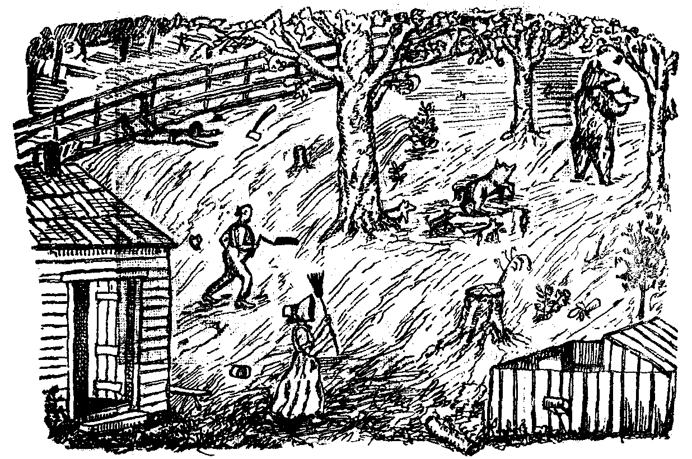
UP BACK OF LACKAWAXEN.

upright on his hind feet, and carrying a pig in his fore paws. The pig was squealing lustily; and struggling to get away. Close upon the heels of the bear came the sow and the rest of the litter, which seemed to know all was not right and made a great uproar. Next followed Mrs. Cole and her three daughters, armed with brooms and such other weapons as they in their haste could secure. Farmer Cole, his two sons and the hired man joined in the pursuit, and a formidable force was presented. At the back of the orchard was a fence. The bear climbed over with his pig, but the fence prevented the sow and her litter from following; the rest, however, followed on, and carried the war into the adjoining field. Farmer Cole gave the hay-knife into the hands of his son James, caught a rail from the fence, and running ahead of the bear, he and the
166 Legends of the Shawangunk.

hired man by taking hold of either end tripped Bruin up. The bear did not lose his hold of the pig, but gathered himself up and made off towards the woods. The rail was held as before, and a second time was he tripped up. This enraged the bear, and he dropped the pig, which was now dead, and made a dash for Farmer Cole. A third time was the animal thrown to the ground, and the men, by holding with all their united strength against the rail, held the bear down until James came up with the hay-knife and cut his throat.

In Southern Ulster there is a burial-ground that in times gone by was set apart for the internment of slaves. The headstones were selected from the fields; and though partially hidden from the casual observer by grass and shrubbery, the mounds and rude monuments can yet be located. Some of the older in-

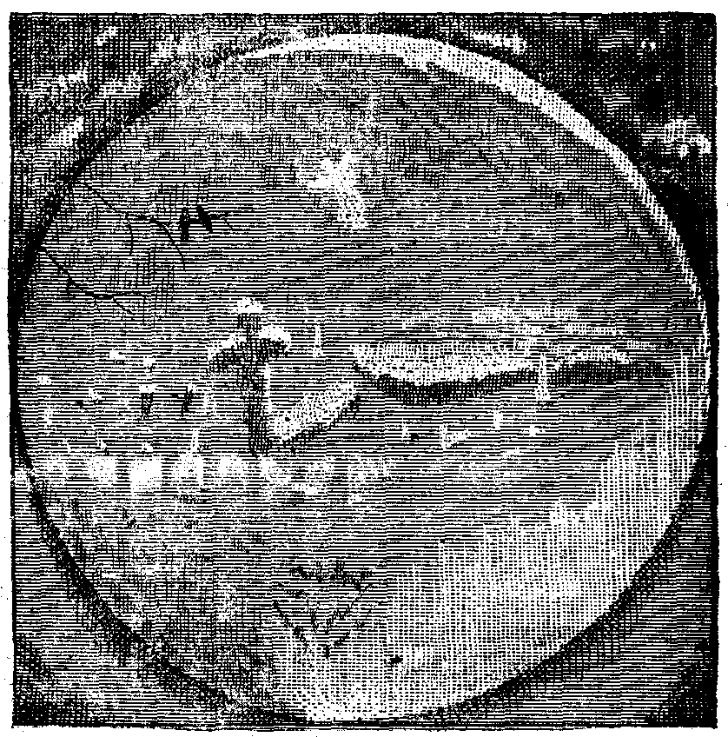
THE SPECTRE.

habitants say that apparitions are sometimes seen loitering among the graves; and that on very dark and stormy nights a figure is seen to rise and soar away into space. In former years, it is said, the ghostly visitant used to frequent a house in the vicinity, and disturb the quiet of its occupants. Sometimes steps could be heard ascending the stairs. Then there would follow the creaking of a door on its hinges, though no door could be seen to move, and a figure in white would advance to the centre of the room, and pause as if intently looking for some object, and then vanish out of sight. The more knowing ones shake their heads when the subject is mentioned, and aver that if the dead could speak, some great wrong would be exposed; that by reason of this great wrong the spirits are not allowed to rest in their graves, but are forced to do penance as punishment for the acts committed during life. It is related that the good dame who once lived there used to punish her diminutive but somewhat refractory husband by doubling him up into a bucket, and letting him
Facts and Fancies. 167

down into a deep well, until his spirit was reduced to something like submission. Be that as it may, there are those living in the vicinity who, when they have occasion to pass the graveyard in the night-time, keep an eye over their shoulder until they get well beyond the ghost-haunted spot.

Yannaker Rosecrans, a domestic in the family of Col. Jansen, was a character in her way. She had a wen growing on her neck half as large as a man’s head. She frequently stood sentry at the house of her employer. One night she detected a number of Indians lurking in the currant bushes near the house. She fired two or three shots in the direction of the sound, and declared some of them were hit, as she presently heard the noise of tomahawks, and supposed the Indians were cutting poles to carry the wounded away. Old people claim she could hold up a barrel of cider and drink out of the “gunnel.” She boasted that no two men could take her alive. It is said that Shanks Ben once lay in ambush for the purpose of taking her prisoner as she came to fodder cattle; but at the sight of her, armed as she was with a huge pitchfork, he declared his heart went “pitty-patty,” until she was out of reach. At another time, while the Colonel had taken refuge in the chimney, she kept the Indians away from the fire-place by throwing hot suppawn at them with a spoon.

It was one of the most melancholy features of the battle of Minisink, that the friends of many of the patriots engaged in that sanguinary conflict were left in painful solicitude as to their fate. Whether killed in the heat of the strife, massacred in cold blood by the marauding savages, left to perish in the wilderness, or carried away captive,—to many of the kinsfolk about Goshen these were questions of conjecture, which only the judgment day will reveal. Major Wood was among the number who failed to return home with the remnant of the little army, and of whom the survivors were able to give little or no account. It could not be determined whether he was among the slain, or of the number taken prisoner. As years went by, and one by one a few returned from their captivity, the wife eagerly sought for tidings of her husband. Her inquires were all in vain, and she finally felt constrained to give him up as lost. After the lapse of several years the widow had a favorable offer of marriage. Though she had no positive proof of the death of her husband, there was little probability of his being yet alive; so acting under the advice of friends, she accepted the offer. The second marriage proved a happy one, and two children blessed the union. Twelve years after the battle of Minisink, Major Wood returned to his home. He had been kept a close prisoner during all that time, and had not once heard of his family. He embraced the first opportunity to escape from captivity; and returned to find that he had long been mourned as dead; that his wife had married again, and had another family growing up around her. Much as it pained him to break the ties that bound the new family together, she was still his wife, for the law would not recognize the second marriage, now that the legal husband was known to be
168 Legends of the Shawangunk.

alive. But the way out of the difficulty was reached in an unexpected manner. The second husband went from home, ostensibly on business, and a few days afterward his hat and some of his clothing were found on the banks of the Delaware. Whether he really committed himself to the mercy of the water with suicidal intent, or only sought to convey the impression that he was dead, while he left for parts unknown, has never been told. Those who knew him best incline to the view that, from motives of compassion for the feelings of his family, he chose the latter alternative. Major Wood lived many years after his return, and his descendants are held in high estimation at the present time.

One of the greatest curiosities, in point of the mysteriousness of its origin in the county of Ulster, is that bit of ancient masonry in the town of Plattekill known as the “Indian Dam.” It is located on what is known as the Levi Bodine farm, now occupied by J. S. Terwilliger, jr. The dam in question consists of two stone walls joined at an obtuse angle, and is about one hundred and fifty yards in length, eight or ten feet in height at the highest part, and four feet in width at the top. It is built across a stream at the outlet of a heavily timbered swamp, and would submerge about one hundred acres. As there is scarcely any perceptible fall, the dam could hardly have been built to furnish water power, hence the question as to the purpose of its construction has never been satisfactorily answered. What is stranger still, when the first settlers came into the vicinity, more than a century ago, the dam was there in the same condition in which it is now found; nor could they ascertain when, by whom, or for what purpose it was built. Though called the Indian Dam, it is not probable the Indians had anything to do with its construction, as they were not given to wall building. Its origin may have been coeval with that of the ancient roads in the vicinity of the Shawangunk mountain, called the “Mine Roads,” indications of which may yet he seen at various points at the foot of the declivities on either side, of which neither history nor tradition can give a satisfactory account.

