LEGENDS OF THE SHAWANGUNK.

THE SHAWANGUNK AND ITS ENVIRONS.

THE Shawangunk is a vast amphitheatre of rocks piled into the most fantastic shapes, with forests covering its crests and slopes, and sporting the exuberance of Nature’s own flower-garden. Here the arbutus, the azalea, and the laurel, successively clothe the sides with vernal beauty.
The summits overlook the valleys of the Rondout and Walkill, beautiful as Paradise, where lie the great grazing and dairy farms of world-wide celebrity; while eastward can be traced the valley of the Hudson, from Cornwall to the mountains about Lake George.
From these airy heights mountain views may be seen such as will strike the beholder with astonishment. On the south the view is bounded by the mountains of New Jersey; the highlands of the Hudson lie to the southeast, with the white sails of sloops and smoke of steamers in Newburgh bay, plainly visible to the naked eye; the Housatonic mountains of Connecticut bound the horizon on the east; the whole line of the Berkshire mountains of Massachusetts, and portions of the Green mountains of Vermont, may be seen to the northeast; while the Helderbergh mountains on the north, the Catskill and Shandaken mountains on the northwest, and the Neversink mountains on the west, complete a panorama in some respects unrivalled in America.
If we are moved with emotions of grandeur at the sublime power of the Creator as manifested in this great panorama of mountains, what must be our feelings, when, under the light of geology, we have presented for our contemplation the convulsions that have brought these mountains into being, and the mutations that have marked their history for unnumbered ages?
The Shawangunk was old before God had formed Adam out of the dust of the ground, and had breathed into him the breath of life; it has witnessed changes in the earth’s condition of which the mind can form no adequate conception. This globe, geologists say, was once in a fluid state; that in cooling, the unequal contraction of the earth’s crust caused some parts to rise above sur-
2 Legends of the Shawangunk.

rounding portions, producing mountain ranges. The whole Appalachian system, of which the Shawangunk forms a part, owes its existence to this agency.
They tell us, also, that this continent, mountains and all, was once submerged beneath the ocean. Marine shells are to this day found imbedded in the rocky crests of Shawangunk; no theory other than that the waves of old Ocean once beat above it can account for their presence there.
This submerging process antedates the period of the deluge of Noah’s time, as is indicated by the organic remains, which are those of extinct animals. Paleontologists estimate the number of species of fossil remains to be more than 12,000, yet scarcely one of this number has been identified with any creature now living.
Gradually the land was elevated to its present level, the ocean receded, and drainage took place from the surface of the earth. Lay bare to-day the rock on which the soil of Sullivan county rests, and it will be found to be furrowed and grooved as the agency of flowing water carried on for successive ages is now known to effect. The general direction of these grooves, together with other evidences, show these vast currents to have come from the north and northwest. Some of the natural depressions, as, for instance, the Mamakating valley, are filled to a great depth by masses of sediment deposited by the water before it receded.
There are examples of denudation in this vicinity; that is to say, the hills have been worn away and lowered, and the deep valleys made still deeper, by tremendous cataracts and surges, as the water rushed violently over high ledges, and fell hundreds of feet into the valley below. While contemplating such a scene, the imagination must fall far short of the reality. The tidal wave that destroyed the port town of Lima, or the surge that overwhelmed the Turkish fleet in Candia, destructive as they were, but faintly shadow the terrific scene.
It requires considerable stretch of the fancy to imagine immense icebergs floating over these mountain peaks, as, swayed by the combined action of wind and current and tide, they impinged against the sides and tops of the elevations; causing those huge rents and fissures that constitute a distinguishing feature of the mountain scenery of this locality.
When the water partially subsided, the ice-floes may have rested on the surface, and were congealed to whatever they came in contact with; and, as they were subsequently home up on the flow of the tide, they detached tons of rock from its parent bed; then, floating over mountain and valley, the débris was deposited when the wasting away of the ice loosened its hold. This seems to be the most plausible theory in accounting for the fact that masses of Shawangunk grit, weighing many tons each, were carried up the western slope and over the tops of the Shawangunk mountain, and deposited near Newburgh, where we now find them.
The series of elevations composing the Shawangunk have decided Alpine character; that is to say, there are numerous peaks elevated above general
The Shawangunk and its Environs. 3

summits, while the summits themselves are broad, wild and rocky. In many places the declivities are precipitous and rugged in the extreme. There are occasional depressions, or passes, which are locally known as “cloves.” The “Pass of the Mountains,” at Otisville, on the line of the Erie railroad, is well worthy of study.
Near the point where the Millbrook stream flows down into the Walkill valley, is a series of remarkable mural precipices, from 300 to 600 feet in perpendicular height. This adamantine wall of parti-colored rock, constitutes one of the distinguishing features of the mountain; and a ramble upon its dizzy heights, where a walk has been laid out along the very brink, provided one’s nerve is strong enough, is an achievement long to be remembered. On the top of this ledge are found the finest specimens of the far-famed Shawangunk huckleberries.
This mountain range, so near to the crowded thoroughfare, yet characterized by such wild and picturesque scenery, with deep intervening valleys, and abounding in natural lakes, has much to interest the artist and the seeker after rest and health. The shades of tint and color, varying with the course of the seasons and the daily changes of the weather, are not to be surpassed in any quarter of the world.
Lying at intervals on the very summit of this mountain, are several considerable lakes of remarkable depth and clearness. Lake Mohonk is especially a romantic body of water, surrounded by masses of huge rocks piled in heaps a hundred and fifty feet high. When twilight descends upon the bosom of the lake, and the great rocks that bend over it send out their shadows athwart its dark expanse, it blends the gloomy, the grand, and the picturesque in a scene that is full of sublimity.
Washington Irving, who once journeyed over this mountain in company with Martin Van Buren, thus describes his impressions:
“The traveler who sets out in the morning from the beautiful village of Bloomingburgh, to pursue his journey westward, soon finds himself, by an easy ascent, on the summit of the Shawangunk. Before him will generally be spread an ocean of mist, enveloping and concealing from his view the deep valley and lovely village which lie almost beneath his feet. If he reposes here for a short time, until the vapors are attenuated and broken by the rays of the morning sun, he is astonished to see the abyss before him deepening and opening on his vision. At length, far down in the newly revealed region, the sharp, white spire of the village church is seen, piercing the incumbent cloud; and as the day advances, a village, with its ranges of bright-colored houses and animated streets, is revealed to the admiring eye. So strange is the process of its development, and so much are the houses diminished by the depths of the ravine, that the traveler can scarcely believe he is not beholding the phantoms of fairy-land, or still ranging in those wonderful regions which are unlocked to the mind’s eye by the wand of the god of dreams. But as he descends the western declivity of the mountain, the din of real life rises to greet his ear, and he soon
4 Legends of the Shawangunk.

penetrates into the midst of the ancient settlement, of which we have before spoken.”
Men are now living in the environs of the Shawangunk whose experience there reads like a western romance. They will tell you of camping in the woods at night, sleeping on a bed of hemlock boughs with only the sky for a covering, on the very spot where populous villages are now located; where, in place of the sound of church bells, and the scream of the locomotive, their ears were greeted with only the shrill bark of the fox, the howl of the wolf, and the soughing of the wind in the tree-tops.
The mythology of the ancients clothed inanimate nature with a new and poetic interest. Every meadow had its fairy, every forest its wood-nymph, and every cascade its water-sprite; while flowery nook and woodland glade were peopled with a merry crew that danced in the light of the harvest-moon, or sported at will in the dew-bespangled grass. These creations of the fancy, while adding a new interest to rural localities, helped to lift the mind out of the prosaic ruts which a dull routine of toil induces, and gave the imagination something more agreeable to dwell upon than the humdrum cares and responsibilities of life.
In like manner it may be said that history and tradition have lent an added charm to the natural beauties of the Shawangunk region. Every lonely road has its tale of tragedy, and every mountain pass its story of encounter with wild beast or savage Indian; every lake has its legend, and every stream its store of border incident.
For untold ages before the advent of the white man the catamount here made his lair, the bear roamed in search of mast, and the deer fed on the lily pads in the upland lake. The wild Indian hunted through its fastnesses, fished from its streams, and, with stealthy and cat-like tread, followed the trail into his enemy’s country.
The rocky sides of old Shawangunk have more than once been reddened with the lurid glare of burning homes; its precipices have echoed back the groans of the dying frontiersman, laid low by a shot from an ambushed enemy; the night winds have born along its rugged outline the shrieks of women and the wails of children, mingled with the war-whoop of the savages, as the work of carnage went on.
Here, too, as we have before intimated, may be found a wealth of rare attractions to the student of geology—in fact, such as will interest all who desire to read the great lessons of creation traced by a Divine hand upon the rocky strata of the mountains, or in the fossils imbedded in the peat and marl of the lowlands. Cabinets of rare value may be collected along these hills and at the excavations of the mines, during a very brief interval of leisure.
The rocks composing the Shawangunk are mainly the shells and sandstones of the Chemung group. “Shawangunk grit” crops out on the west side of the mountain, and has been quite extensively used as millstones, locally known as “Esopus millstones.” The entire mountain has been pretty thoroughly examined from presumed indications of veins of coal.
The Shawangunk and its Environs. 5

At the foot of the western slope the Bashaskill and Neversink river flow southwardly; on the east side the Shawangunk kill runs in a northerly direction, all the streams lying close under the base of the mountain. This same peculiarity is observed in the Walkill and Hudson rivers, their general coarse lying parallel to each other, yet flowing in opposite directions.

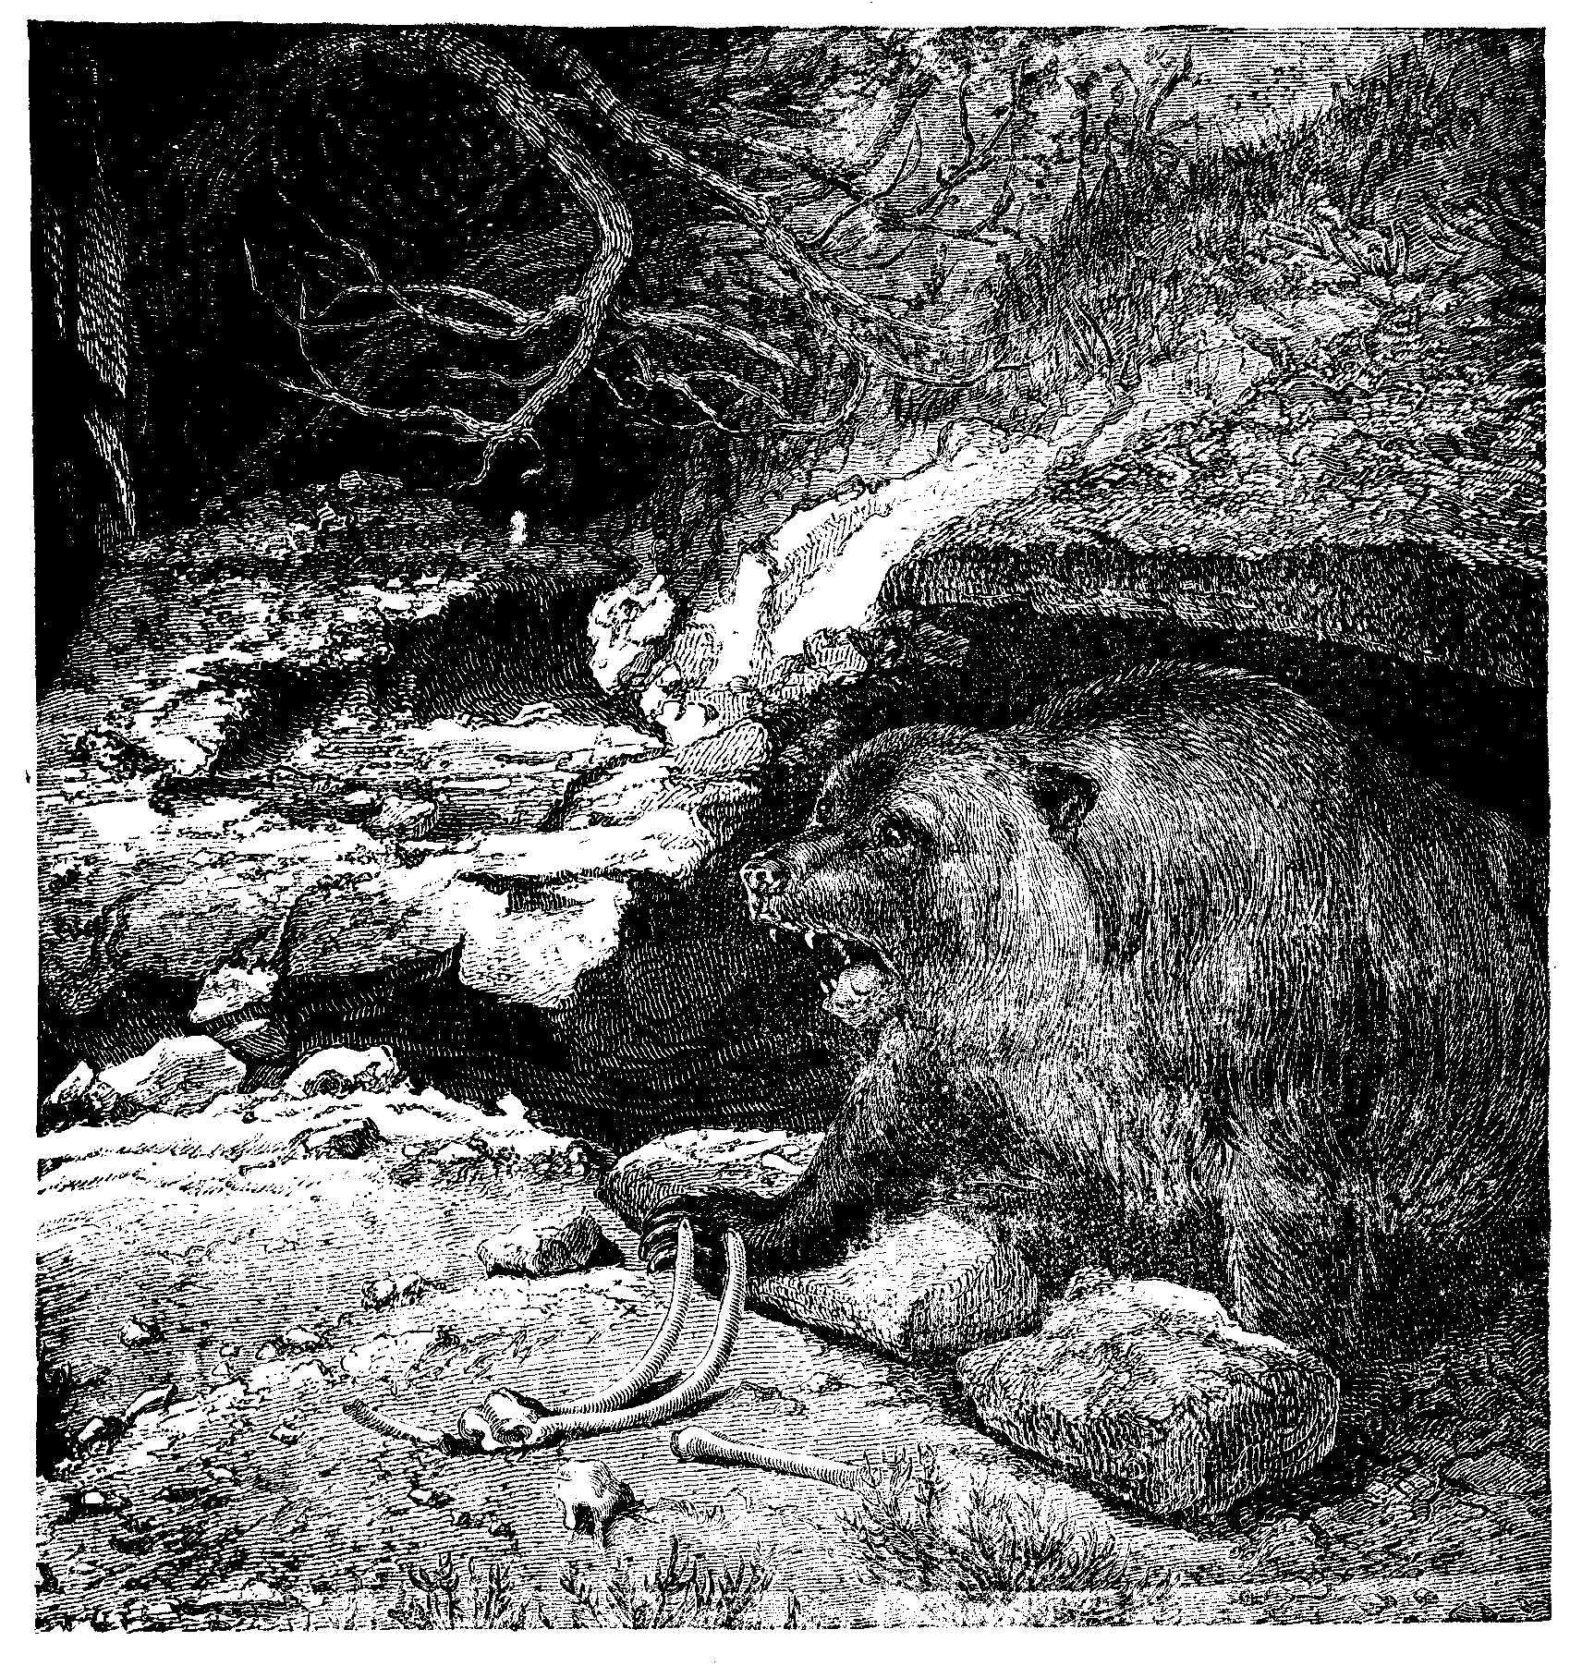
A NATIVE SHAWANGUNKER.

The whole range is intersected by metalliferous veins. Besides, the vicinity is so full of traditions of Indians obtaining both lead and silver in abundance, and at so many points in the mountain, that it is looked upon as a bed of ores of undisputed riches. The openings to the mines were carefully concealed, as is asserted, by the Indians and early settlers, and with their death perished all
6 Legends of the Shawangunk.

knowledge of the location of the minerals. Stickney relates an account given of two men who worked a sliver mine somewhere in the mountain, previous to the Revolutionary war. This mine was shown them by some Indians; they carried on operations with the utmost secrecy, working only at night and making long and mysterious journeys to dispose of their ore. When the war broke out they joined the army, each pledging the other not to reveal the secret until the war was ended. One cold, dark night they drew a large flat stone over the mouth of the mine, strewed leaves over the place, and at the distance of thirty paces east marked three trees which stood close together.
One of the men never returned from the war; the other was absent nine years. His family meanwhile had fled for safety to a distant village, and his first duty was to look after their welfare, and provide for them another home in the forest in place of the one destroyed. When he had leisure to look after the mine he found that predatory bands of Indians had burned the marked trees, and obliterated the natural landmarks, and he was unable to locate the mouth of the mine. No one has to this day removed that stone from the entrance to this cavern of mineral treasure.
Another old gentleman related that his father once saw the mine. At his earnest and repeated solicitations, a friendly Indian chief consented to take him to it, but he must allow himself to be blindfolded. He was accordingly led for a distance into the wilderness up hill and down dale, and finally went down into the heart of the mountain, as he judged by the dripping of the water on the rocky sides of the cavern. At length the bandage was taken from his eyes, and he stood before a solid vein of silver. Though he many times searched all through the mountain, he could never afterwards find the place. Old residents say “every seven years a bright light, like a candle, rises at twelve o’clock at night above the mine, and disappears in the clouds; but no one that has ever seen it has been able in daylight to find from whence it arose.”
It is related that the savage Unapois, beholding a gold ring on the hand of a white woman, demanded why she carried such a trifle. He was answered by the husband of the lady, “If you will procure me such trifles I will reward you with things suitable for you.” “I know,” said the Indian, “a mountain filled with such metal.” “Behold,” continued the other, “what I will give you for a specimen,” exhibiting a fathom of red and a fathom of blue frieze, some white lead, looking-glasses, bodkins and needles, and tendering the savage an escort of two soldiers. The Indian declined the escort, but accepted the presents, and promised to give a specimen; if it gave satisfaction he might be sent back with some of the white people.
After some days the Indian returned with a lump of ore as large as his fist, which was found to be of good quality, and a considerable amount of gold was extracted from it, and made into rings and bracelets. The Indian was promised further presents if he would disclose the situation of this mountain. Unapois consented, but demanded a delay of a few days, when he could spare more time. This was acceded to, and after having received more presents he returned to his
The Delawares. 7

nation. He indiscreetly boasted of his presents, and declared the reason of their presentation, which led to his assassination by the sachem and others of his tribe, lest he should betray the situation of the gold mine. There was a prediction current among the Indians to the effect that after their people had passed through a period of punishment for some great offence they had committed, the Great Spirit would once more smile upon them and restore them to the land of their fathers, and they wished to reserve those mines against their return.

THE DELAWARES.

THE Indian of the Western continent belongs to the “bow and arrow” family of men. To him the chase meant everything. When the advent of Europeans drove the deer from the forests and the beaver from the natural meadows, and the pursuit at hunting was no longer profitable, the red man pined and wasted away as though his life was robbed of everything that made existence desirable. The Indian could form no higher ideal of earthly happiness; and his most blissful conception of Paradise was that of a hunting-ground abounding in game, and where the streams and lakes swarmed with fish.
A characteristic of the American Indian is a dislike for restraint. A degree of personal independence incompatible with a state of society in which each individual’s actions are modified from consideration for his neighbor, has ever caused the Indian to chafe under the restrictions imposed by civilization. The greatest chief among them had no delegated authority. His power to rule was founded on public opinion, and when that was against him, he was no more than a common savage; but when largely in his favor, his power was despotic. To be foremost in danger, and bravest in battle, were requisites necessary to sustain himself in authority.
Another propensity of the Indian is a passion for war. He followed the war-path because it gratified the most deeply seated principle of action in the savage breast, a thirst for revenge; and also because that was the only means by which he might hope to satisfy his ambition, and rise to a position of authority and influence in his tribe. With the aboriginal the forgiveness of an injury was reckoned a weakness, while revenge was considered among the nobler virtues. Tales of bloody, retributive vengeance were told about their council fires, by way of inciting the young warriors to deeds of similar daring.
The Indian believed in a Great Spirit, everywhere present. He believed also in the existence of subordinate spirits, both good and bad. He belonged to a singularly superstitious race, and put the most implicit faith in dreams and omens. When disease came among them, when the chase was unsuccessful, when their crops failed or they were defeated in war, they thought the Great Spirit was displeased with them; at such times they would perform religious
8 Legends of the Shawangunk

ceremonies with great earnestness and solemnity, by way of propitiation of his wrath.
Among them the dance was universal; but it was not for purposes of pastime, as among civilized nations. It had a deeper signification. It was a solemn ceremony, and was an outward expression of their sentiments of religion and war.
It is the logic of events that the red man yields to the conquering foot of the Saxon. The weaker race has withered from the presence of the stronger. “By the majestic rivers and in the depths of the solitary wood, the feeble son of the ‘bow and arrow’ will be seen no more; the cypress and hemlock sing his requiem.”
The Delawares related a legend to the effect that many centuries ago their ancestors dwelt far in the western wilds. Emigrating eastwardly, after many years, they arrived on the Namœsi Sipu (Mississippi), where they encountered the Mengwe (Iroquois), who had also come from a distant country. The spies of the Delawares reported that the country on the east of the river was inhabited by a powerful nation, dwelling in large towns erected upon the principal rivers.
This people were said to be tall and robust, warlike, and of gigantic mould. They bore the name of Alligewi (Alleghany); their towns were defended by regular fortifications; many vestiges of which are yet apparent. The Delawares, requesting to establish themselves on their territory, were refused; but obtained leave to pass the river that they might seek a habitation farther to the eastward. The Alligewi, alarmed at their numbers, violated their word and destroyed many of the Delawares who had reached the eastern shore, and threatened a like fate to the remainder, should they attempt the passage. Roused at this act of treachery, the Delawares eagerly accepted a proposition from the Mengwe, who had hitherto been spectators of the occurrence, to unite with them for the conquest of the country.
A war of extermination was then commenced, which eventuated in the expulsion of the Alligewi, who fled from their ancient seats never to return. The devastated country was apportioned among the conquerors, the Mengwe choosing the neighborhood of the lakes, and the Delawares appropriating the territory further to the south.
For many years the conquerors lived together in much harmony. Some Delaware hunters, having penetrated far into the forest, discovered the great rivers, the Susquehanna and Delaware; and crossing the Skeyickby (New Jersey) country, came at last to the Mahicannittuck (Hudson river). Upon their return to their nation, they described the country they had visited as abounding in game, fish, fowl and fruits, but destitute of inhabitants. Summoning together their chiefs and principal men, after solemn and protracted deliberation it was concluded that this was the home destined for them by the Great Spirit; and thither the tribe went and took up their abode, making the Delaware river, to which they gave the name of Lenapewihittuck, the centre of their possessions.
The Delawares. 9

The Mengwe, thus left to themselves, hovered for a time on the borders of the great lakes with their canoes, in readiness to fly should the Alligewi return. Having grown bolder, and their numbers increasing, they stretched themselves along the St. Lawrence, and became near neighbors to the Delawares on the north.
In process of time the Mengwe and the Delawares became enemies. The latter said the Mengwe were treacherous and cruel, and pursued an insidious and destructive policy towards their more generous neighbors. Not daring to engage in open warfare with the more powerful Delawares, the Mengwe resorted to artifice to involve them in a war with distant tribes. Each nation had a particular mark upon its war-clubs, which, placed beside a murdered victim, denoted the aggressor. The Mengwe killed a Cherokee warrior, and left with the dead body a war-club with the mark of the Delawares. The Cherokees, in revenge, fell upon the latter, and commenced what proved to be a long and bloody war.
The treachery of the Mengwe was at length discovered, and the Delawares turned upon their perfidious neighbors with the avowed purpose of extermination. They were the more induced to take this step, as the cannibal practices of the Mengwe* had reduced that nation, in the estimation of the Delawares, below the rank of human beings.
Hitherto the tribes of the Mengwe had acted each under its particular chief. Being so sorely pressed by the Delawares, they resolved to form a confederation, the better to control their forces in war, and regulate their affairs in peace. Thanwewago, a Mohawk chief, was the projector of this alliance. Under his auspices, five nations, the Mohawks, Oneidas, Onondagas, Cayugas and Senecas, formed a species of republic, governed by the united councils of their aged sachems and chiefs. To these a sixth was afterwards added, the Tuscaroras of North Carolina.
The effect of this centralization of power early manifested itself. The Iroquois confederacy became a terror to their enemies, and extended their conquests over a large part of the territory lying between the Atlantic and the Mississippi. The Delawares were frequently at war with the Dutch, and, if tradition is to be believed, the Dutch and Iroquois conspired for their destruction. However that may be, the confederated tribes, having been taught the use of fire-arms by the whites, soon asserted a supremacy over the less fortunate Delaware Indians, and the latter were reduced to the condition of a conquered people.
According to a tradition among the Delawares, their forefathers were once fishing at a place where the Mahicannittuck widens into the sea, when they beheld a white object floating upon the water. Word was sent to the village, and the people came to view the wonder. Various conjectures were made as to what it could be. Some thought it was an immense animal floating upon

* The Mengwe, or Iroquois, sometimes ate the bodies of their prisoners. It is said, too, of the Algonquins, that they drank their enemies’ blood.
10 Legends of the Shawangunk.

the water; others said it was a huge fish; others still believed it to be a large wigwam.
As the apparition moved steadily toward the land, the natives imagined they could discover signs of life in it. Their chiefs and wise men were summoned together; after mature deliberation they came to the conclusion that it was a very large wigwam, in which the Great Spirit resided, and that he was coming to visit them. This decision created a profound sensation among those simple children of the forest. The Manitou, from whom they received the choicest gifts, and who so seldom made himself visible to his creatures, was about to land upon their shores, and be seen by them and converse with them.
The sacrifice was prepared, the best food provided, and a dance ordered to honor him, and appease his anger if his mood were wrathful. Fresh runners arrived who declared their strange visitant to be an immense floating wigwam, and that it was crowded with living creatures. Later still, other messengers reported the living things were human beings, with pale faces and strange garments, and one of their number was clad in magnificent apparel. The latter they decided was the Great Manitou himself.
In due time their wonderful visitors landed. Some of the natives were overcome with fear, and were about to run away and hide themselves in the woods; but the wise men and warriors of the tribe tried to prevent such an exhibition of cowardice, and counselled that they unite in giving a fitting reception to their marvellous guests.
A large circle of their principal men was formed, towards which the men in gold lace approached, accompanied by two others of the pale faces. Salutations were given on both sides. The Indians could not conceal their wonder at the brilliant ornaments and white skin of the supposed Manitou; they were sorely puzzled when they found he did not understand the words of his children, and that he spoke in a language unintelligible to them.
While they were regarding him with a respectful gravity, a servant brought a large hack-hack (gourd), from which was poured a liquid which the Great Being drank, and then offered to one of the chiefs. The savage looked at it, then smelled it, and was not pleased with its pungent odor. It was then to the next chief, who followed the example of the first, and gave the vessel to the one next to him. In that manner it was transferred to each one in the circle, and it was about to be returned to the supposed Manitou, when a great and brave warrior conceived the act would be disrespectful to the Deity, and forthwith harangued the warriors on the impropriety of their conduct. He explained that while it would be meritorious to follow the example of the Manitou, to return what he had given them might displease him, and lead him to punish them. The speaker would, therefore, drink the contents of the cup himself, and though he perished, the sacrifice would save his nation from destruction. Having proclaimed his laudable intention, he bade his followers farewell, and drank the contents of the cup. Soon he began to exhibit signs of intoxication. While the natives were regarding him with interest, supposing
The Delawares. 11

him to be under the effects of the poison, he fell to the ground. His companions imagined he was dead, but he was only dead drunk.
Presently, the would-be martyr exhibited signs of life; and when he had sufficiently recovered from his fit of intoxication to speak, he told the assembled chiefs that the liquor had given him the most pleasing sensations that he had ever experienced. All of them had an anxiety to feel these sensations. More of the intoxicating beverage was solicited; the cup this time was not passed without being tasted; and a general debauch followed. The supposed Manitou was Henry Hudson; and this was the first visit of the white man to the country of the Delawares.
The territory embraced between the Hudson and the head-waters of the Delaware, now included in the counties of Orange, Ulster and Sullivan, is a region of peculiar interest. Less than three centuries ago these valleys and hills swarmed with villages of the Leni-Lenape; and now not one representative of the aboriginal occupants of the soil remains among the scenes sacred to the memory of his fathers. The story of the causes that led to their extinction, and to the peopling of their Muck-cos-quit-tais, or “corn-planting grounds,” by pale-faced usurpers, is a tale of thrilling interest, and is well worthy a niche in history.
The council seat of the Leni-Lenape or Delawares was at Minisink, near the junction of the Neversink and Delaware rivers. Here the chiefs and principal men of the nation met to decide the questions relating to the welfare of their people; here they smoked the pipe of peace, or determined the question of carrying war into the territory of their enemies.
Near Cochecton was the Indian village where the clans met, in accordance with their ancient customs, to celebrate their green-corn dances, their dog-festivals, and indulge in their favorite pastime of La Crosse. On the banks of the Hudson was the famous Danskamer, or “Devil’s Dance Chambre,” where burned the religious fires of the natives, that were never suffered to go out, lest the wrath of the Great Spirit should be aroused from their negligence.
When the white strangers came from over the sea, these natives shared with them their hunting-grounds, and generously set apart, for their use, fields for planting. Esopus, and other early settlements of Ulster, lay along the old Indian trail connecting the Hudson with the head waters of the Delaware, while the ancient settlement of Peenpack grew and flourished in the heart of the Delaware country. Thus the savages, thrown into frequent communion with the whites, were initiated into some of the customs of their more civilized neighbors; while the latter not infrequently adopted some of the habits of their dusky friends.
For years the hardy pioneers and their red brothers would live amicably together, fishing from the same streams, hunting through the same forests, and tilling contiguous fields of corn. Occasional broils would break out between the two races, in which the Indians were not always the aggressors. When savage ferocity was once roused, the work would be decisive and san-
12 Legends of the Shawangunk.

guinary. Without a moment’s warning, in the silent, unguarded hours of slumber, the settler’s home would be invaded with terrific war-whoop and murderous tomahawk, and the whole family massacred or carried away into captivity.
It is to be observed that the difficulties between the Delaware Indians and their white neighbors, which caused so much bloodshed on both sides, originated mainly from misunderstandings in regard to lands. The natives claimed, and not without reason, that they were cheated in their transactions with the Dutch; that the latter assumed possession of more land than was sold to them; and that boundaries and lines were altered, and always in favor of the whites. It cannot be denied that the Indians were not always paid the full stipulated purchase price, and were overreached by their more wily pale faces in various reprehensible ways.
Lossing, in his “Field Book of the Revolution,” gives an instance in point. The natives had conveyed a territory to the “Proprietors of Pennsylvania,” the boundaries of which were to extend a certain distance on the Delaware or “Great Fishkill” river, and as far back, in a northwest direction, as a man could travel in a day and a half. The Indians intended the depth of the tract should be about fifty miles, the distance a man would ordinarily walk in the specified time. But the purchasers employed the best pedestrians in the colonies, who did not stop by the way even to eat while running the line; the expiration of the day and a half found them eighty-five miles in the interior! The Indians boldly charged them with deception and dishonesty.
The “Proprietors” claimed that they had become the owners of the lands within the Forks of the Delaware river, by a regular form of conveyance, and that the Indians had been fully paid for them. The Delawares, on the other hand, denied the validity of the sale, and asserted that they had never received a stipulated consideration. The case was, in 1742, laid before the Six Nations for arbitration, who, after hearing both sides, decided that the disputed territory could not be sold by the Delawares, as they were a conquered people, who had lost their right in the soil; that if the lands did not belong to the white people, it was the property of the Six Nations. With two such rivals for claimants, as the scheming whites and the dreaded Iroquois, the Delawares were fain obliged to forego their claim to the disputed territory. Some years ago a quantity of old spurious coin was dug up near Otisville, on the line of the Erie railroad. It was so clumsily executed as to preclude the supposition that it was the work of a gang of counterfeiters. The more reasonable theory is that it was intended to be used to cheat the Indians as they were not the best judges of money.
Such treatment ruffled the tempers of the Delawares, and predisposed them to make other complaints. They declared that the whites had spoiled their hunting-grounds; that they had destroyed the deer with iron traps; and that the traders of Minisink always made the Indians drunk when they took their peltries there, and cheated them while they were in that condition. The period
The Delawares. 13

of the French and Indian war was now approaching; and had the settlers of the Shawangunk region adopted a different policy in their treatment of the Delawares, and so predisposed their dusky neighbors in their own behalf, many of the atrocities which thrilled and startled the people of that frontier would have been averted. While the Dutch and English were building up a wall of enmity between themselves and the Indians by adopting a course of treachery and artifice, the more wily French emissaries were making good use of that very circumstance to incite them against the English occupants of the territory, and so win them over to the interests of the French monarch. The results of the over-reaching policy of the Dutch and English recoiled with terrible effect on their own heads.
The defeat of Braddock, in July, 1755, on the banks of the Monongahela, was another of the causes that led the Indians of the whole territory of the Delaware to take sides with the French. That defeat, so discreditable to the military prestige of Great Britain, entirely destroyed the influence of the English with those tribes.
Once the murderous tomahawk was unburied, the whole frontier, from Virginia to the banks of the Hudson, at once felt the dire effects of savage ferocity. The following description does not overstate the reality: “The barbarous and bloody scene which is now open, is the most lamentable that has ever appeared. There may be seen horror and desolation; populous settlements deserted, villages laid in ashes, men, women and children cruelly mangled and murdered, some found in the woods, very nauseous, for want of interment, and some hacked, and covered all over with wounds.”
During the winter ensuing, the enemy continued to hang on the frontiers. A chain of forts and block-houses was erected along the base of the Kittanning mountains, from the Neversink river to the Maryland line, and garrisoned by fifteen hundred volunteers and militiamen under Washington. It may not be generally known that Benjamin Franklin once engaged in a military campaign. He received the appointment of Colonel, and in the service of defending this chain of forts, he began and completed his military career, being convinced that war was not his chosen calling.
By September of 1756 it was estimated that one thousand men, women and children had been slain by the Indians, or carried into captivity. Property to an immense amount had been destroyed, and the peaceful pursuits of civilized life were suspended along the whole frontier. Although Colonel John Armstrong subsequently administered a severe chastisement upon the savages in their den at Kittanning, killing their chiefs, slaughtering their families; and reducing their towns and crops to ashes, yet scalping parties continued to penetrate into the Mamakating and Rondout Kill valleys, some of them venturing into settlements east of the Shawangunk mountains. Under these circumstances, for the settlers to remain on their farms was to court death in a hideous form. The majority of the women and children were removed to Rochester, Wawarsing, New Paltz, and other localities for protection.
14 Legends of the Shawangunk.

The reduction of Canada by the English, and the consequent overthrow of the French power and domination on the western continent, did not afford our frontiers entire immunity from savage atrocity and outrage, as the settlers had hoped. An era of better fellowship seemed to be dawning between the two races, which for awhile seemed to promise much; but when the War for American Independence broke out, the natives again entered upon the war-path, urged thereto by British influence, and, as has been asserted, and by facts substantiated, by proffers of British gold.
The Delawares are no more seen along the rivers and valleys of the Shawangunk region. If the blood of the Leni-Lenape of the Neversink and Walkill valleys yet flows in the veins of the living, it is to be looked for in the scattered remnants of the Indian clans of the far distant west.
The Indian, like his prototype the Mastodon, who aforetime roamed through these fertile valleys, bids fair, as a race, to become extinct. Years ago, a poor, friendless Delaware came into the vicinity, the last of the tribe that was ever seen here. He was last noticed at Bridgeville, Sullivan County, where he was made the sport of a lot of vicious boys. A Mr. Rice, then an invalid, whom all supposed in an advanced stage of consumption, rescued him from his tormentors, and gave him a hat and some money. The Indian received them gratefully, and after gazing thoughtfully for some time on his benefactor, he left the neighborhood, never more to return. Some months elapsed, and the incident had nearly passed out of mind, when Mr. Rice received a letter from the Indian, in which the latter gave a minute description of his complaint, with directions for its cure. The treatment was undertaken, and the remedy proved so efficacious, that Mr. Rice’s health was completely restored. The grateful savage had travelled forty miles from his home in the wilderness to deposit his letter in the post-office.
Competent judges have pronounced the Delaware language the most perfect of any Indian tongue, it being distinguished, they say, by “great strength, beauty, and flexibility.” The tribe have left behind them, as mementoes of their former dominion over the soil, names that they gave to mountains, streams and localities. No people, ancient or modern, bestowed more beautiful names on water-courses and valleys than did the Delawares. However long one may have been accustomed to perfect euphony and exact rythm, these appellations delight the ear as does the rich, sweet cadence of the hermit thrush that sings upon their banks—such words, for instance, as Wyoming, Mamekoting, Moyamensing and Osinsing. Their names of mountains, on the other hand, are harsh and rugged, as Shawangunk, Mohunk, Wachung, Scunnemunk, and others.
The First Esopus War. 15

THE FIRST ESOPUS WAR.

IT is a peculiar feature of American history that many of the earlier settlements owe their establishment to the religious persecutions of the old country. Sometimes the Catholics drove the Protestants from their homes to find refuge in strange climes, as the French did the Huguenots at the Revocation of the Edict of Nantes; and again we behold a Protestant persecuting dissenters and Catholics alike, as the English did the Puritans of New England and the Romanists of Maryland. Another relic of old Europe, the outcome of the ancient feudal system, was the custom of granting large tracts to individuals called Patroons, thus establishing a system of tenantry, with the Lord of the Manor as the chief head. Both these causes, as we shall see, contributed to the settlement of Ulster county.
Holland at that time was denominated a “cage of unclean birds,” because, it being a government founded on religious tolerance, all religions flocked there. Some English and French Walloons, who had found temporary refuge among the Hollanders, afterward emigrated to America, and settled at Rensselaerwyck. The management of the affairs of the Patroon of that section had been given to Brandt Van Schlectenhorst, “a person of stubborn and headstrong temper.” This man was very earnest in defending what he considered the rights of his lord against the Governor of New Netherland and the West India Company. Stuyvesant claimed a jurisdiction about Fort Orange, and insisted that the Patroon was subordinate. Van Schlectenhorst denied both, and went so far as to dispute Stuyvesant’s right to proclaim a fast in his jurisdiction. To insure allegiance, the Patroon pledged his tenants not to appeal from his courts to the Governor and Council; and finally, orders were issued for tenants to take the oath of allegiance to the Lord of the Manor. This bold proceeding Governor Stuyvesant was moved to call a crime. Some of the settlers sided with the Governor, and others with the doughty Van Schlectenhorst; the dispute at last ran so high that the two factions came to blows.
Among these tenants was one Thomas Chambers, an Englishman by birth, “tall, lean, with red hair, and a carpenter by trade.” He was one of the Walloons that fled from his home to escape religions persecution, only to find himself involved in the troubles about the proprietary rights of the new country a quarrel in which he had no interest; subject to the whim of his landlord or his commissary, treated as a slave, and victimized by covetous officers. He and his companions, therefore, cast about them for a new settlement, “where they could work or play, as seemed best to them.” Chambers emigrated to the vicinity of Troy; but finding he was still on territory claimed by his old landlord, he removed to Esopus, having heard the land there was good, and that the savages had expressed a desire that the Christians would come among them.
16 Legends of the Shawangunk.

Tradition says they landed at the mouth of Esopus Creek, and journeyed up until they reached the flats of Kingston. Here Chambers received a “free gift” of territory from the natives.
In 1655 a general war broke out between the Indian tribes on both sides of the Hudson, and the whites of Amsterdam and vicinity. When the news of this outbreak reached Esopus the inhabitants all fled, leaving their stock, dwellings and crops to the mercy of the savages. This action was the more necessary, as the few inhabitants were living scattered on their farms, without even a block-house for protection. During their absence their empty houses and unprotected grain was appropriated by the Indians. Albany records say the farmers returned to their homes as soon as peace was restored.
It had been the purpose of the Directors of the West India Company to construct a fort at Esopus, and orders had been issued to that effect. The orders were not obeyed, hence the unprotected state of the settlement. The savages had their wigwams all around the farms of the white people, and their maize-fields and bean-patches were near to each other. The hogs, cows, and horses of the settlers roamed at will on the untitled flats, frequently destroying the crops of the Indian women. This made the Indians mad, and they complained of the depredations of the stock to the owners, but the animals still roamed.
Now and then a pig was found dead with an arrow or bullet in it. Now it was the Christian’s turn to get mad. Still it might have been possible for the whites and Indians to have lived together in comparative amity, but for an additional source of trouble.
Jacob Jansen Stohl, agent for the Governor at Esopus, wrote to Stuyvesant to the following purport: “The people of Fort Orange (Albany) sell liquor to the Indians so that not only I, but all the people of the Great Esopus, daily see them drunk, from which nothing good, but the ruin of the land, must be the consequence.”
In these transactions the whites were sometimes more to blame than the savages, and yet they wrote in this wise: “Christ did not forsake us; He collected us in a fold. Let us therefore not forsake one another, but let us soften our mutual sufferings.”
In a letter from Thomas Chambers to Governor Stuyvesant, dated May, 1658, we find additional evidence of the baneful effects of the strong drink sold to the savage. He writes in substance: “I saw that the savages had an anker (ten-gallon keg) of brandy lying under a tree. I tasted [it] myself and found it was pure brandy. About dusk they fired at and killed Harmen Jacobsen, who was standing in a yacht in the river; and during the night they set fire to the house of Jacob Adrijansa, and the people were compelled to flee for their lives. Once before we were driven away and expelled from our property; as long as we are under the jurisdiction of the West India Company we ask your assistance, as Esopus could feed the whole of New Netherland. I have informed myself among the Indians who killed Harmen, and they have promised to deliver the
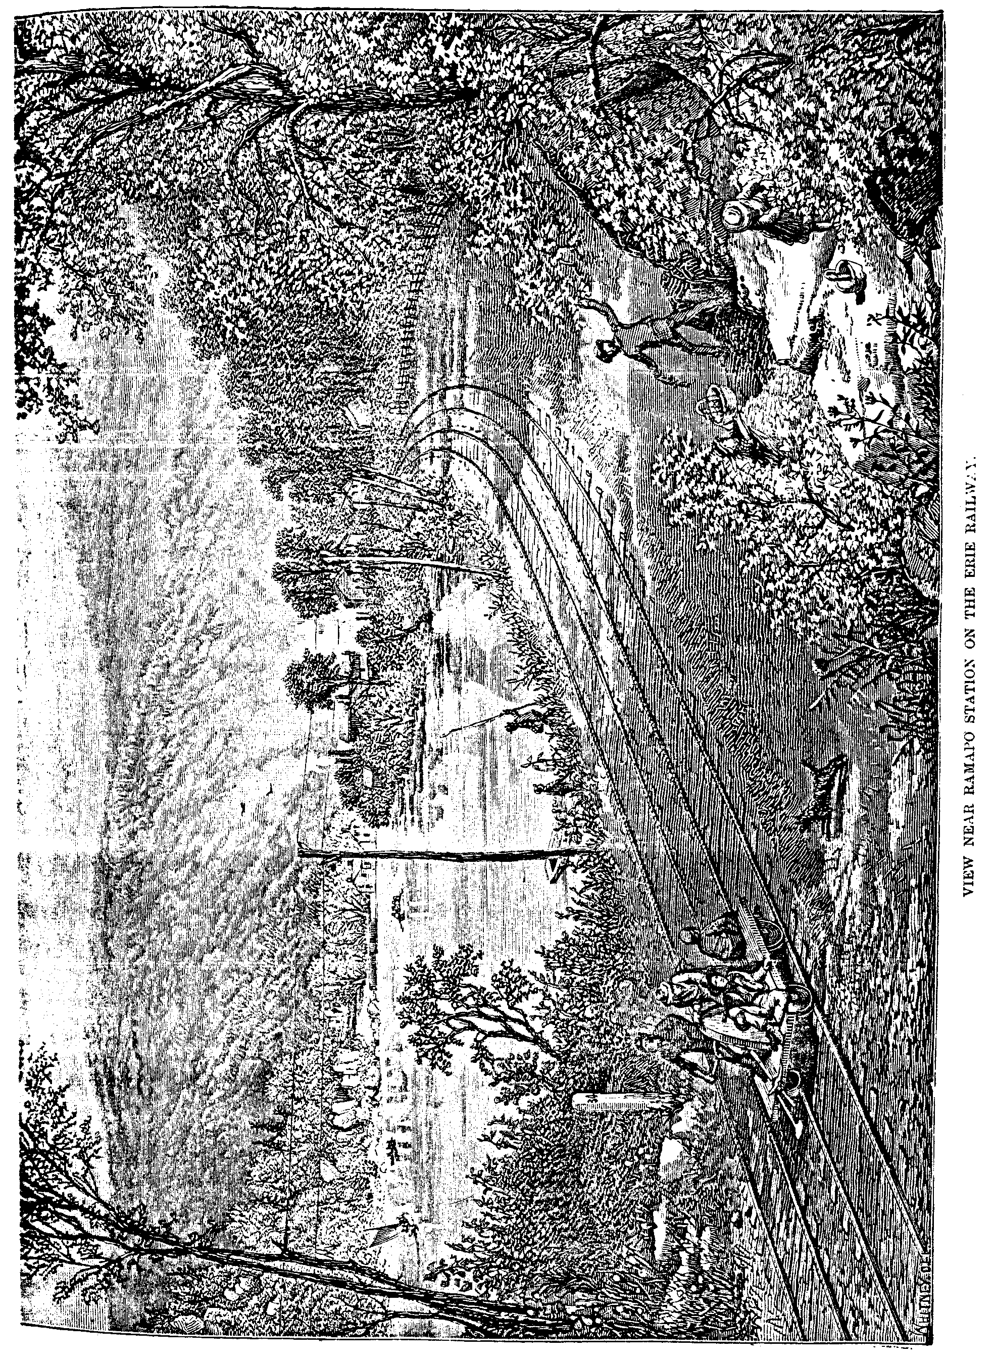

The First Esopus War. 17

savage in bonds. Please do not begin the war too suddenly, and not until we have constructed a stronghold for defense.”
The following month Chambers again wrote:—“We have done our best to apprehend the murderer, but have been mockingly refused by the barbarians. In answer to our inquiry who sold them the brandy, the savages refer to no one in particular, but to many, now Peter, then Paul. It is evident that it is not for the sake of selling their stock of beavers alone that they keep near Fort Orange (Albany), where, as the make of the brandy keg proves, the coopers have hardly sufficient time to supply the demand by these people. The savages set fire to the cow-shed, the pig-sty, and then the dwelling-house of Jacob Adrijaensen, and not being satisfied, compelled us here to plow for them. Upon our refusal they take firebrands and hold them under the roofs of our houses, to set fire to them. The common savages do not pay any attention to their chiefs, as the latter seem to have lost their authority. We are obliged to remain in our houses, as the savages would immediately attack us when we stir about, and set everything on fire; therefore we request your favor for a succor of forty or fifty men.”
In response to the above letters, at a meeting at which were present Honorable Director-General Peter Stuyvesant and three councillors, the following action was taken: They took up and seriously considered the letters from Esopus. By the first they were informed that the savages had killed Harmen Jacobsen and set fire to two houses, and behaved and acted very insolently and wantonly; by the second the savages were continuing in their intolerable insolence and boldness, forcing the people there to plow for them, etc. It was therefore resolved that the Director-General should go there forthwith, and fifty or sixty soldiers as a body-guard, to make arrangements. This Director-General was no less a personage than Peter the Headstrong, of whom Washington Irving gives the following facetious description:
“Peter Stuyvesant was the last, and, like the renowned Wouter Van Twiller, the best of our ancient Dutch governors, Wouter having surpassed all who preceded him, and Peter never having been equalled by any successor. He was of a sturdy, raw-boned make, with a pair of round shoulders that Hercules would have given his hide for, when he undertook to ease old Atlas of his load. He was, moreover, not only terrible for the force of his arm, but likewise of his voice, which sounded as if it came from a barrel; and he possessed an iron aspect that was enough of itself to make the very bowels of his adversaries quake with terror and dismay. All this martial excellence of appearance, was inexpressibly heightened by an accidental advantage, that of a wooden leg; of which he was so proud that he was often heard to declare he valued it more than all his other limbs put together. Like Achilles, he was somewhat subject to extempore bursts of passion, which were rather unpleasant to his favorites and attendants, whose perceptions he was wont to quicken, after the manner of his illustrious imitator, Peter the Great, by anointing their shoulders with
18 Legends of the Shawangunk.

his walking staff.” The following is embodied in the journal of Governor Stuyvesant’s visit to Esopus:
“We left in the private yachts on the 28th day of May, arriving at the kill of the Esopus on the 29th. To avoid commotion among the savages, or causing their to flee at the sight of so many soldiers before they could be spoken with, I ordered the accompanying yachts to follow separately at a distance, and not to anchor near me before nightfall, nor to show too many soldiers on deck at once. I sent a barge ashore opposite to two little houses of the savages, to invite two or three of the Indians aboard. The barge presently came bath with two savages, and also Thomas Chambers and another man, who were induced to come down to look for help from the good south wind and expected relief. I persuaded the savages by a little present to go inland and induce the Indian sachems to meet me at the home of Jacob Jansen Stohl the following day, his being the last dwelling in contiguity, or the day after that, assuring them that no harm should come to them or theirs. They agreed to do it, and were put on shore after I had some further talk with the two Christians, Chambers and Van Der Sluys. The other yachts arriving during the evening passed by us who were aground close to the shore. I ordered the soldiers landed with the least possible noise, without beating the drum; which being done, they were to send for me and my people on my yacht. We marched the same evening to the ‘bouwery’ of Thomas Chambers, that being the nearest, for the night. On the morning of the 30th, that being Ascension Day, we marched to the house of Jacob Jansen Stohl, nearest to the habitations and plantations of the savages; where we had made the appointment to meet them, and where, on Sundays, and at the usual feasts, the Scriptures were read.
“When the people had assembled in the afternoon I stated to them that I had come with sixty soldiers, asking of them their opinion of what it were best to do; that I did not think the present time was favorable to involve the whole country in a general war on account of the murder, the burning of two small houses and other complaints about threats of the Indians; that now in summer, with the prospect of a good harvest, it was not the proper time to make bad worse, least of all by giving room too hastily to a blind fear; that it was not in our power to protect them and the other outlying farmers as long as they lived separately from each other, and insisted upon it contrary to the order of the Company.
“They answered they should be ruined and indigent men if they were again obliged to leave their property, which result would follow if they could get no protection against the savages. I told them they could get no protection as long as they lived separately; that it was necessary that they should remove together at a suitable place, where I could and would assist them with a few soldiers until further arrangements were made; or they might retreat with their wives, children, cattle, and most easily removed property to the Manhattans, or Fort Orange for safety; but if they could make up their minds to neither, they must not in future disturb us with complaints.
The First Esopus War. 19

“Each was of opinion that it was dangerous to remain in their present condition; there was a good harvest in prospect, with which they hoped to sustain their families the coming winter; to abandon those fertile fields at this juncture would occasion great loss, and entail upon them and their families abject poverty. The necessity of a concentrated settlement was at length conceded, but it was thought impracticable to effect the removal of the houses and barns before harvest time, in addition to the labor of inclosing the place with palisades. They plead very earnestly that the soldiers might remain with them until after the harvest; this I peremptorily refused, and insisted that they should make up their minds without delay. To encourage them I promised to remain with the soldiers until the place was enclosed with palisades, provided they went to work immediately, before taking up anything else. Another difficulty presented itself—each one thought his place the most conveniently located for the proposed enclosure. But on the last day of May the inhabitants brought answer that they had agreed unanimously to make a concentrated settlement, and each had acquiesced in the place selected, and in the final arrangements. The grounds were staked out that same afternoon.
“In response to my request of the Indian chiefs for a conference, twelve or fifteen savages made their appearance at the house of Jacob Jansen Stohl, but only two chiefs were among them. They explained that the other sachems would not come before the next day; that they were frightened at so many soldiers, and hardly dared to appear; also that they had been informed that more soldiers were to follow.
“After assurances on my part that no harm should befall them, they became more cheerful; and the same evening about fifty savages made their appearance at the house of Stohl. After they had all gathered under a tree outside of the enclosure, about a stone’s throw from the hedge, I went to them, and so soon as we had sat down, they, as is their custom, began a long speech, telling how in Kieft’s time our nation had killed so many of their people, which they had put away and forgotten.
“I answered that this all happened before my time, and did not concern me; that they and the other savages had drawn it all upon themselves by killing several Christians which I would not repeat, because when peace was made the matter had all been forgotten and put away among us [their customary expression on such occasions].
“I asked them if since peace was made any harm had been done to them or theirs; they kept a profound silence. I stated to them and upbraided them for the murders, injuries, and insults during my administration, to discover the truth and authors of which I had come to Esopus at this time, yet with no desire to begin a general war, or punish any one innocent of it, if the murderer was surrendered and the damages for the burned houses paid. I added that they had invited us to settle on their lands in the Esopus, that we did not own the land, nor did we desire to until we had paid for it. I asked why they had committed the murders, burned the houses, killed the hogs, and did other injuries.
20 Legends of the Shawangunk.

“Finally one of the sachems stood up and said that the Dutch sold the ‘boison’ [brandy] to the savages, and were the cause of the Indians becoming ‘cacheus’ [crazy] mad or drunk, and that then they had committed the outrages; that at such times they, the chiefs, could not keep in bounds the young men who were then spoiling for a fight; that the murder had not been committed by any one of their tribe, but by a Neversink savage, that the Indian who had set fire to the houses had run away and would not be here. That they were not enemies; they did not desire or intend to fight, but had no control over the young men.
“I told them if the young men had a desire to fight to come forward now; I would match them, man for man, or twenty against thirty or even forty; that now was the proper time for it; that it was not well to plague, injure or threaten the farmers, or their women and children; that if they did not cease in future, we might try to recover damages. We could kill them, capture their wives and children, and destroy their corn and beans. I would not do it because I told them I would not harm them; but I hoped they would immediately indemnify the owner of the houses, and deliver up the murderer.
“To close the conference I stated my decision: that to prevent further harm being done to my people, or the selling of more brandy to the Indians, my people should all remove to one place and live close by each other; that they might better sell me the whole country of the Swannekers [Dutch] so that the hogs of the latter could not run into the corn-fields of the savages and be killed by them. The chiefs then asked through Stohl and Chambers that I would not begin a war with them on account of the late occurrence, as it had been done while they were drunk; they promised not to do so again.
“On Monday, June 3d, the soldiers with all the inhabitants began work on the palisades. The spot marked out for a settlement has a circumference of about 210 rods,* well adapted by nature for defensive purposes; and when necessity requires it can be surrounded by water on three of its sides. To carry on the work with greater speed and order I directed a party of soldiers and experienced wood-cutters to go into the woods and help load the palisades into wagons; the others I divided again into parties of twenty men each, to sharpen the palisades and put them up. The inhabitants who were able were set to digging the moat, who continued to do so as long as the wind and the rain permitted.
“Towards evening of the 4th of June a party of forty or fifty savages came to where we were at work, so that I ordered six men from each squad to look after their arms. After work had been stopped they asked to speak to me. They informed me they had concluded to give me the land I had asked to buy to ‘grease my feet,’ as I had come so long a way to see them. They promised in future to do no harm to the Dutch, but would go hand in hand and arm in arm with them.

* Dutch rod 12 feet.

